Energetic Algae (‘EnAlgae’)

Project no. 215G

Public Output

OutputWP2A09.02 – Report on the state of algae related research and industrial activities in France
Authors
Mona-Maria Brinker, Agency for Renewable Resources (FNR e.V.)

Contributors
Kristin Sternberg, Agency for Renewable Resources (FNR e.V.)

Please cite this document as follows:

Brinker, M-M, Sternberg K.2014. Report on the state of algae related research and industrial activities in France, Public Output report of the EnAlgae project, Swansea, [month and year of release], [number of pages]pp, Available online at [website link].

This document is an output from the Energetic Algae (‘EnAlgae’) project, which has received European Regional Development Funding through the INTERREG IVB NWE programme.

© EnAlgae project partnership, [date of release], all rights reserved.

Report on the state of algae related research and industrial activities in France

Contents
1 Introduction 2
2 French stakeholders 3
3 Types of algae 9
4 Cultivation facilities 11
5 Growth conditions 13
6 Markets 14
7 Underpinning activities 18

Introduction
In 2012-2014 an inventory of North-West European algae initiatives was carried out to provide an impression of research and commercial activities connected to algae production and utilization. The collected data has been reviewed in country specific reports and collated and summarized in an overview report covering the whole North-West-Europe region (including Great Britain, Ireland, Germany, Belgium, France, Switzerland, Luxemburg and the Netherlands).
Data was obtained via a comprehensive questionnaire (Annex 1) which was distributed among stakeholders identified in a preliminary scoping exercise. Although not unexpected, not all questionnaires were filled out by the stakeholders and returned to the EnAlgae programme. In these cases, publically available information was used for the landscaping study. The questionnaire aimed to gather more information on focus, expertise and applied technology of the addressed institutions. It was also designed in a way that allows its use as an information sheet in EnAlgae’s web-based information portal and the Decision-Support-Tool (DST).
This report summarizes the results of the analysis of data collected in France. For the purpose of clarity, the following analysis has been differentiated between research institutions and industrial enterprises.
It must be emphasized that this report cannot claim to reflect an exhaustive list of all stakeholders active in algae research and business. The reasons behind this are:
It is a rather broad area and in some cases only very limited information is available about respective activities. In addition, there is a lot of movement in the algae sector with regard to new start-ups and the closing down of business operations, making it difficult to maintain an up-to-date overview. If too little information could be found about certain institutions they were not included in this survey.
However, this study nevertheless represents the most important institutions active in the algae area, allowing conclusions to be drawn about the main fields of interests, technology and market opportunities for algal research in France.
More information on macro-algae industries in France can be also found in two big algae projects in France. For more information on the macro-algae industry and research in France, please visit the Netalgae project or the Idealg project.

French stakeholders
In total 50 institutions working with algae could be identified in France. The majority of these stakeholders (65 %) are working commercially with algae whereas the other 35 % of stakeholders are mainly research oriented. Table 1 gives an overview about the identified stakeholders, sub-divided into commercially active representatives and academic research oriented stakeholders.

Table 1: Overview of French stakeholders active in the broader algae area
Commercial stakeholders
AGRIMER | AGRIMER is an industrial company leader in harvest, transformation and valorisation of the marine resources. AGRIMERs know-how lies in the fields of cosmetics, health food, pharmacy and agriculture. AGRIMER harvests and processes around 20 different species of seaweeds.
Alèor | Alèor is active in seaweed farming, building on innovation processes, specifications and know-how. Alèor is mainly a production company, but is also involved in several research projects dealing with seaweed cultivation and harvesting.
AlgaeStream | Development and sale of its "Algae Tunnel" bioreactor system for large scale production, targeted at customers using algae biomass for food, feed, pharmaceutics, energy and bioremediation.
Algenics | Algenics is a pharmaceutical company; it develops recombinant biotherapeutics for human health by leveraging a microalgae-based technology. Algenics, as a marine biotechnology company is specialized in genetic engineering and physiology of microalgae.
Algoplus | Algae harvesting and food processing.
Algosource Technologies (AST) | Services in conceptual engineering. Process development for photosynthesis and biorefining of microalgae, as well as CO₂biosequestration. Development and valorisation of microalgae industrial processes.
Algues et mer | Extraction of active ingredients for cosmetics and nutraceuticals from seaweed.
Alpha Biotech | Development of new culturing procedures and culturing of new species; focus on accumulation of metabolites like pigments, lipids and polysaccharides. Development of photobioreactors and automatisation. Production of microalgae in different photobioreactors inside and outside with controlled production parameters. Processing of the algae biomass (extraction, filtration) into semi-final products for cosmetic industry. Production of liquid Spirulina extracts
Aqua B | Cultivation, harvest and transformation of marine algae. Aqua B is specialised on food products
Aquacoled'Ouessant | Harvesting of seaweed to produce food, food additives and cosmetics
Bio Molenez | Harvesting and processing of green, red and brown macro-algae. Cosmetic production from macro-algae.
BIOALGOSTRAL | Sustainable and economic viable production of microalgae, primarily for energetic use. Bioalgostral aims to produce algae-based biofuels, further use of algae biomass for agronutrition and cosmetics.
BIOCEAN | BIOCEAN is a raw material supplier for the food and cosmetics industry. BIOCEAN collects, cultivates and transforms seaweed. Biocean is specialized in harvesting underwater and seaweed farming. BIOCEAN offers fresh seaweed, frozen and dehydrated.
Cargill | Cargill is one of the world's largest agribusinesses. Cargill produces alginate from macro algae in its French factory in Lanillis.
ChemSud | ChemSud (Chemistry for a Sustainable Development) is a foundation dedicated to chemistry and sustainable development. ChemSud is involved in the project Algasud whose aim it is to develop and allow structuration of algae industry in Languedoc-Roussillon.
Codifrecherche et nature | CODIF Recherche et Nature is cultivating macro-algae in the sea and macro- and micro-algae in photobioreactors. CODIF provides the raw materials for the cosmeceutical industry.
La Compagnie du Vent | Focusing on research on renewable energy
C-Weed aquaculture | Commercial production of macro-algae.
Eco-Solution | Development and sale of evolved micro-organisms aiming to improve overall performance in industrial biological processes  Development of a technology platform to help select and develop new micro-organisms by "in vivo evolution" (acceleration of natural evolution )  Applications: improving biological processes relating to the production of biogas; improving production of biofuels based on enriched microalgae
ESETA | ESETA is an engineering company that has expertise in the field of energy and industrial, agricultural and urban thermal processes.  The ESETA projects lie both in the process of research and development and the pre-industrialization.
Fermentalg | Biotechnology company specialized in the research and production of micro-algae using heterotrophic and mixotrophic mode of culture.  Products: applications in healthcare and cosmetics, agro-food, biofuel and green chemistry.
GREENSEA | Production of micro- and macro-algae (more than 400 strains) and focus on certain parameters according to customer needs;  A worldwide availability of macro-algae, a production capacity of more than 50,000 litres for microalgae  Production of marine ingredients ( derivatives of macro-algae or microalgae), one of the world leaders in highly purified phycobili-proteins (photosynthetic pigments)  GREENSEA is a company dedicated to R&D innovation and its practical application for industrial exploitation of microalgae covering thus various industries such as cosmetics, nutraceutical, aquaculture, pharmaceutical and energy.
INNOVALG | Tank culture of both micro and macro algae.
Legumiers de la mer | Association of professionals in the production of macro-algae for food purposes, to promote the development of seaweed and sea vegetables market
Microphyt | Operates and sells innovative photobioreactors for mass production of fragile and/ or slow growing species  Production and sale of algae biomass according to customer's needs. Microphyt develops new technologies of production of microalgae adapted to various needs and locations, with the production at low cost for the large world mass markets as objective.
Olmix | Olmix philosophy is to find natural alternatives to the traditional chemistry, valuing environmental resources. Their division Green Tech on raw material researches and develops additives from macro-algae.
Penn Ar Bed | Penn Ar Bed produces food additives using multiple nutritional properties of algae.
Phycosource | PHYCOSOURCE is a company specialized in plant biotechnology and in the search for high added value active substances.  Phycosources specialisation: - collecting techniques;  - strain isolation;  - growth on a solid medium and screening of culture media;  - high-speed culture on a line of automatic Phycotron  Discovery and valorisation of compounds from microalgae  Product focus: cosmetics & "biotech pipeline"
RoquetteFréres | Heterotrophic production of microalge for production of nutritional ingrediences; currently production of 5000 t chlorella per year in fermentors. Products: nutrients-enriched food ingredients made from the microalgae under the brand algility™. The line of products include whole algal flour, whole algal protein, and algility™ chlorella.
Scirsée | Production of spirulina in open ponds using waste heat of a biogas plant. They target the market of nutraceuticals (food and food supplement).
Soliance Blue, Marine biotechnology | Soliance Blue, marine biotechnology is active in the production of molecules from micro-algae. They develop cosmetic active ingredients from microalgae
Scientific Stakeholders
AgrocampusOuest, Halieutic resource pôle | Was coordinator for the Netalgaeproject , is involved in IDEALG project (WP8). In IDEALG, AgrocampusOuest focuses on a seaweed marketing study in France (consumption and market). Otherwise focus is not only on Algae
BezhinRosko | BezhinRoskos purpose is to do independent scientific research on seaweeds, particularly on the laboratory model alga Ectocarpus, to provide consultancy related to marine macro-algae, and to deliver algal strains from the BEZHIN ROSKO culture collection. The scientific research of BEZHIN ROSKO concentrates on the biology of the model brown alga Ectocarpus, investigating its life history, ecology and taxonomy.
CEA Cardarache - Laboratory of Microalgal and Bacterial Bioenergetics and Biotechnology | Research aims at exploring the potential of microalgae for the durable production of biofuel (hydrogen, biodiesel):  - understand the metabolic pathways and the electron transfer pathways involved in the process of hydrogen photoproduction; finding ways of improvement of the process  - studying the molecular mechanisms of oil accumulation in microalgae and identifying master regulators of oil biosynthetic pathways in order to maximize the capacity of lipid production by microalgae  - Algomics (2009-2012)  System-level approach (genetics, genomics, proteomics, metabolism, physiology, process engineering) to unravel key metabolites and regulatory elements involved in the control of the energetic metabolism of microalgae.
Centre d'Etudes et de valorisation des algues (CEVA) | CEVA is divided into 4 departments, each having its own competencies : 1) Algae & Environmental Quality:  - Expertise in algae ecology and coastal oceanography  - Development of metrics to monitor water quality  - Environmental monitoring  - Monitoring and modelling of macro-algal eutrophication  - Support to aquaculture (potential area, yield prediction, …)  2) Algae Raw algae:  - Assistance to algae producers and harvesters for a sustainable exploitation of the biomass  - Development and optimization of sustainable cultivation techniques  - Algae chemical composition management through specific culture conditions (stress)  - Promotion of integrated algae and animal aquaculture to reduce the impact of traditional aquaculture on the environment  3) Algae products  - Development of commercial applications of algae in Food, Feed, Agriculture, Cosmetic, Chemistry, material and Energy markets.  - Biotechnological processes for biomass stabilization, transformation, extraction of active compounds and chemical modification.  - Applied R&D on algae products and processes development.  - Technology transfer of developed processes.  4) Analysis & Knowledge Management
EcoleCentrale Paris, R2DS | Using microalgae as CO2 sinks: proposal for a method of intensive cultivation and ways of producing biomass
GEPEA (Génie des procédés, environment, agroalimentaire - from University of Nantes); associated with CNRS (UMR CNRS 6144) | - Development and improvement of photobioreactors for microalgae cultivation  - Treatment of marine water with phytoplancton  - biofuel production with microalgae (biodiesel, biokerosine)  - CO2 from flue used by microalgae  - Valorisation of macro-algae through extraction of useful bioactive ingredients  - Research on hydrogen production through Chlamydomonasreinhardtii  - Development of a biorefinery concept for production and processing of microalgae Porphyridiumcruentum (for extraction of a pigment with fluorescenting characteristics)
Heliobiotec | Heliobiotec is a biotechnological platform was organized in 2008 to investigate the potentialities of microalgae for the power production
Ifremer - French Institute for Marine Research - Physiology and Biotechnology of algae | The Ifremer laboratory is divided into two teams: The "Ecophysiology" team studies relationships between microalgae and their environment, and the effects of such relationships on the growth and biochemical composition of marine microalgae. The "Algae and Genomes" team applies biochemical and molecular approaches to study microalgae metabolisms inherent to defined physiological conditions. Functional genomics tools are utilized to identify and characterize genes and metabolic pathways of interest that could reveal biotechnological potential. Ifremer participates in the following R&D projects:  Salinalgue: the project aims to cultivate Dunaliellasalina on a large scale in an open environment on unexploited salt marshes, and then process or ‘biorefine’ it to yield various bioproducts: biodiesel, biogas, molecules with high added value and proteins for aquaculture feed: Ifremer handles all aspects of biological culture for the operation  Factor 4: A platform geared to selected autotrophic microalgae production, and notably configuring the key elements of such a platform in terms of mutation, tagging, selection, screening and containment techniques. The overall objective is to produce robust strains, and increased potential for strains from algae stocks.  AMICAL: The aim is the development of a new business chain in New Caledonia: cultivation and use of endemic microalgae; Establishment of Research Centres; Selection of promising species, development of pilot plants and testing of economic viability  Symbiose: Behavioural studies of complex microalgal-bacterial cultures, with a view to their optimization, along with expertise in microalgae culture technologies. Whole project aim: objective was to develop an effective two-stage production process combining a microalgae production stage that fixes CO₂, and a second, methane-producing stage with fermentation of the microalgae produced. The «Symbiosis» loop created by this process will recycle nutritive elements such as nitrogen and phosphorus within the microalgae production system.  Company focus: advising on the technical feasibility of installing intensive and/or extensive microalgae production units
INRA - Laboratory of Environmental Technology (LBE) | The Laboratory of Environmental Biotechnology (LBE) is a research unit of the French National Institute for Agricultural Research (INRA). The LBE is an innovation concentrate focused on the concept of the environmental biorefinery. The aim of the research conducted at the LBE is the treatment and the valorisation of emissions linked with human activities: liquid effluents (mainly of food origin), solid wastes (agricultural residues, household wastes and sewage sludge) or specific biomasses such as micro or macro-algae. LBE is involved in the projects Greenstars and Idealg.
Inria Sophia Antipolis - BIOCORE team | BIOCORE is a joint INRIA (Research Unit in Sophia-Antipolis), INRA (sites in Sophia Antipolis and LBE Narbonne) research-team.  The overall goal of BIOCORE is to contribute to environment preservation by developing new energy sources, avoiding water pollution and replacing the use of chemicals for crops. In this context, the objective is to design, model, analyse, control and optimize artificial ecosystems (designed by man, built by man, or profoundly modified by man).
INSA Toulouse, Laboratoired'Ingénierie des SystèmesBiologiques et des Procédés LISBP & EAD6 | Comprehensive understanding and biotechnological applications of microalgae
PôleMer PACA | Department Marine biological resources, bleu technologies and sustainable aquaculture: New applications for marine biological resources. The scientific area of PôleMerPaca is linked to industrial operations. Marine and environmental biotechnologies primarily concern fundamental research in molecular biology and genetics as well as research related to molecules of therapeutic or industrial interest (cosmetics, nutrition and pharmacology …). In the future, this research is expected to lead to related applications: e.g. nanotechnologies, bio-fuels, CO2 capture.  Involved in several algae projects: Shamash: The goal of this project is to test a new procedure for high-yield production of microalgae for use in the production of a new biofuel. Alcomics: Some microalgae can produce molecules with high energy content (hydrogen or lipid) used for the production of biofuels. The project objective is to raise ALGOMICS locks limiting biological production capacity of these microorganisms, appropriating concepts necessary for advanced domestication process of conversion and storage of solar energy, EIMA: Mass production of microalgae through digestion / recovery of carbon substrates (industrial by-products) Factor4: Improvements of microalgae through strain selection (non-GMO) Greenstars: Biofuels from microalgae, Heliobiotec: Hydrogen and biodiesel from microalgae, Phytoiron: Mechanisms of iron assimilation in marine micro-algae Salinalgue: develop cultures of native microalgae (Dunaliellasalina) large-scale environment of open and undeveloped salt refinery to market different bioproducts including a next generation biofuel with high performance in terms of production yield per hectare and reduce the emission of greenhouse gases (GHGs).
Station Biologique de Roscoff, Algal Genetics Group, UMR7139 CNRS UPMC | Fundamental research into brown algal development. Genome analysis.
Université de Bretagne-Sud UBS | The LBCM works on a "marine biofilms" by offering an innovative approach based on interdisciplinary. The group Biotechnology - Valuation of marine molecules focuses on the objective of purification and structural characterization of natural compounds isolated from marine organisms for their recovery.
University Blaise Pascal, Institut Pascal, Process engineering, Engineering thermodynamics and Biosystems (GePEB) | Bioreactors engineering and bioenergy production processes: this includes photobioreactors engineering, microalgae cultures, anaerobic fermentative processes and bio-hydrogen production. GePEB also focuses on biomolecules production processes and biorefinery: this concerns oligosaccharides production processes, bioconversions and the improvement of bioremediation processes.
University of Brest, Laboratory of Ecophysiology and Biotechnology of Halophytes and Seaweed | The research themes of LEBHAM lie in the field of physiology and biochemistry of halophytes and algae in relation to their environment. The emphasis is on understanding and monitoring of the plant communities of the Breton coastal environment. On the other hand, an important aspect of the work lies in the study of substances of economic and eco-physiological interests (cell wall polysaccharides, materials stress, bio-active molecules).
University of Caen, BioMEA | Marine primary producers (phytoplankton, microphytobenthos, macro-algae) are particularly studied by coupling work on ecology, ecophysiology, biodiversity and algal biotechnology. Work on the trophic ecology and habitat networks are based on the use of biomarkers (isotopy, lipids, sterols) and the BioMEA group studies particularly important physical and biological coupling at the coastal ecosystem of the Channel.

Types of algae
The usage of micro- and macro-algae is very evenly distributed among the French stakeholders (38 % are working with micro-algae, 38 % are working with macro-algae). Nearly a quarter of all stakeholders (23 %) is cultivating and processing both macro and micro algae types (23 % of the industrial stakeholders and 27 % of the research institutions).
55 % of the stakeholders provided information about the algae specie(s), on a varying degree of accuracy (ranging from answers like “seaweed” to species names), The majority of these stakeholders are using green algae (33 %, figure 1) and macro-algae (22 %). Overall, the use of algae types varies significantly, with few species (such as Chlamydomonasreinhardtii and Chlorella vulgaris) being used slightly more than others (see figure 2).
Based on the provided data, it was detected that a considerable amount of stakeholders work with cyanobacteria. Although cyanobacteria are not algae from a scientific perspective, they are often mentioned in the context of micro-algal activities. Some of the stakeholders have focused on both microalgae and cyanobacteria. For this reason the work with cyanobacteria was also included in this overview.

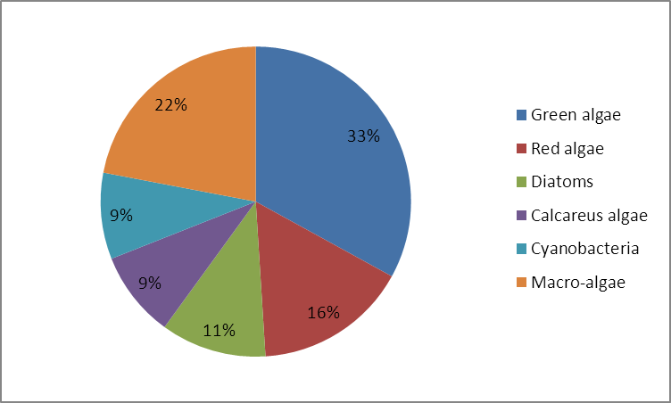
Figure 1: Used algae types in France

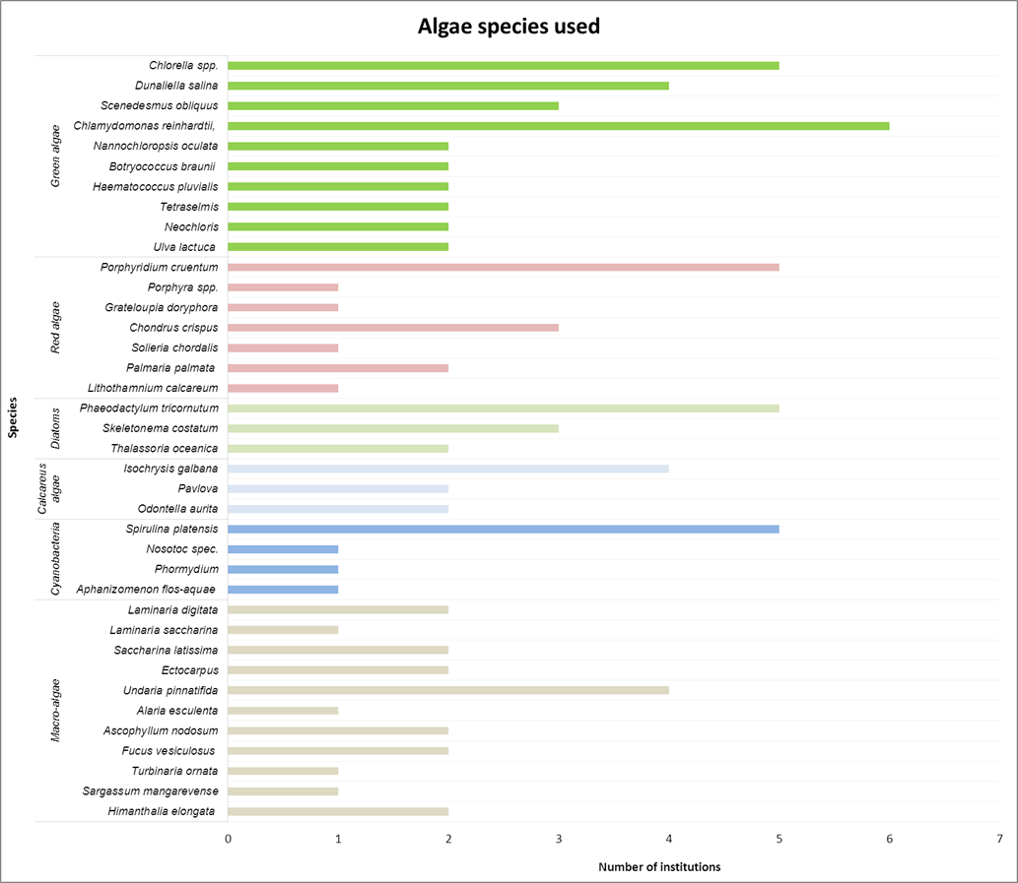
Figure 2: Number of institutions working with these algae species (multiple answers permitted)

Cultivation facilities
Over the last decade, constant and innovative research and development has been taking place in the area of algae cultivation technology. The presently used cultivation systems can be subdivided into following systems:

Table 2: Cultivation systems
Open/ Half-open production systems
- Open-Ponds
- Race-Way-Ponds
- Longlines
Closedphotobioreactorsystems (PBR)
- Flat bed/ Plate/ Flat panel reactor
- Tubular reactor
- Bag/ Flexible tube reactor
- Rain creating stack system („Horizon“)
- Fermentation vessel (heterotrophiccultivation)

Closed cultivation systems have the advantage of better controlling the cultivation conditions and, consequently, to guarantee the best temperature and light regime under almost sterile conditions.
Closed photobioreactors (PBR) are the most favoured facilities for cultivating microalgae in research institutions in France. A lot of different PBR systems are utilized for microalgae production, the most common systems are tubular photobioreactors followed by fermentation vessels and plastic bags. Open ponds also play a role (figure 3 and 4) in the French micro-algae production. Flexible structures, such as long lines, and wild harvest are considered by stakeholders working with macro-algae and are especially used by commercial algae stakeholders in France. Especially wild harvest of macro-algae contributes to the commercial algae activities in France.

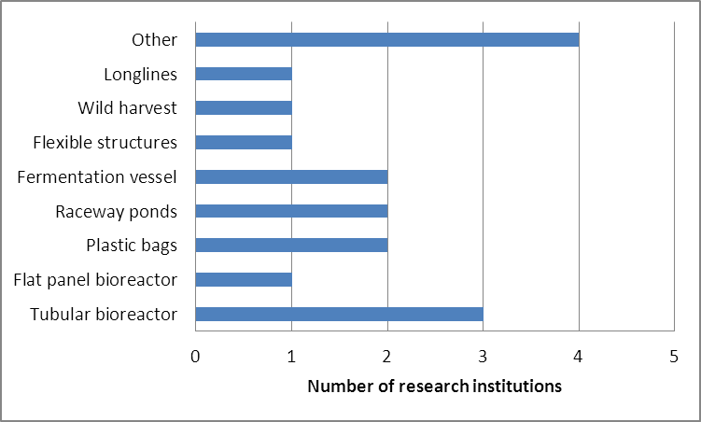
Figure 3: Cultivation facilities at research institutions

Both industry and research institutions have a strong interest in constantly improving their algae cultivation systems or, respectively, to develop or test new ones. This is mainly reflected by the number of stakeholders working with “other” cultivations systems than the most common ones named in the questionnaire (24 % of the research institutions and 14 % of the industrial stakeholders; figure 3 and 4). Altogether, a higher number of different of cultivation systems are used at research institutions.

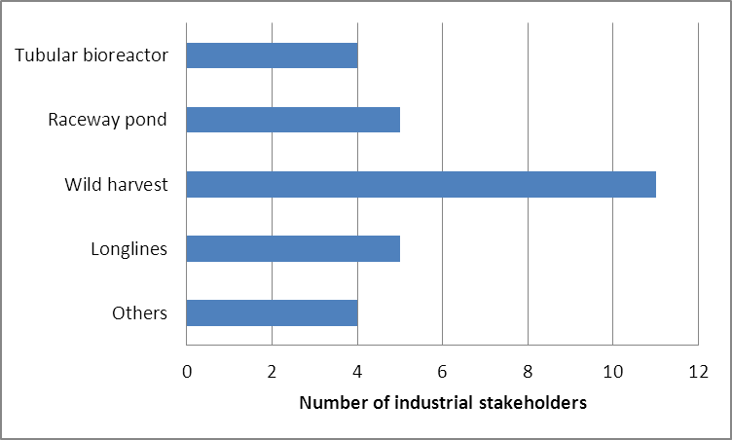
Figure 4: Cultivation facilities in industry

In regard to size of the facilities there is naturally a big difference between academia and industry, as well as between the usages of macro- and micro-algae.
We have received too little information on the size of the cultivation facilities to give more than a general statement. Usually the industrial and scientific macro-algae cultivation area ranges from 6-1000 ha, whereas the scientific microalgae research facilities can be carried out in a petri-dish (answers here ranged from 2.4 m³ – 56 m³ cultivation areas).

Growth conditions
Only 60 % of the questioned stakeholders provided information about the conditions in their respective algae growth facilities. In respect to growth conditions, the survey did not go into too much detail, but rather concentrated on the origin of the three main substances: water, light and carbon dioxide. Multiple answers were possible.

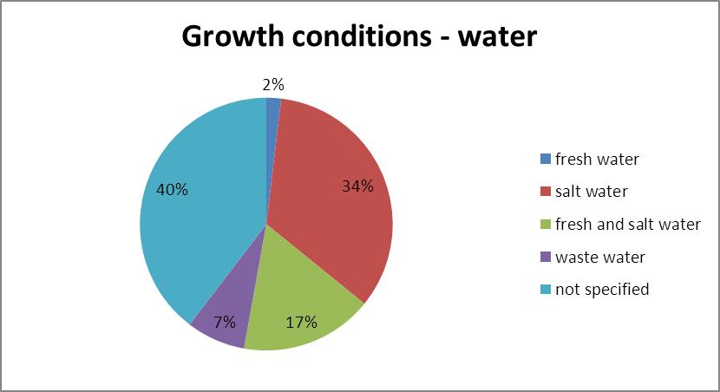
Figure 6: Growth condition – water

In regard to the growth medium, a majority of the stakeholders cultivate their algae in salt water (34 %) or grow algae in both fresh and salt water (17%). The algae cultivated in exclusively fresh water only accounts for 2 % in France, according to the results of this survey. Even the usage of waste water to cultivate algae exceeds this surprisingly low percentage with 7 %. The waste water sources are quite different and comprise process waters as well as municipal wastewaters and liquid fractions of digestates.

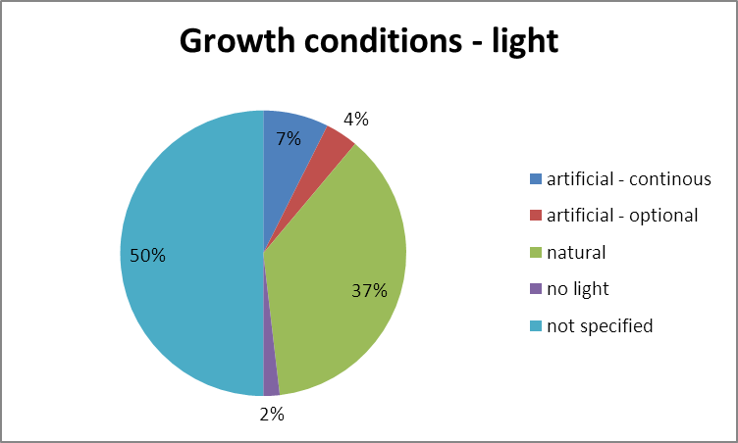
Figure 7: Growth condition - light

In terms of the light regime, the majority of the stakeholders, who provided respective information, use natural light for growing algae: 37 % solely rely on the natural radiation whereas 4 % of the stakeholders use artificial light when possible as an option (figure 7). Only 7 % of the stakeholders exclusively use artificial light for their algae cultivation. Only 2 % of the stakeholders have (also) focused on heterotrophic microalgae production and do not use any light.

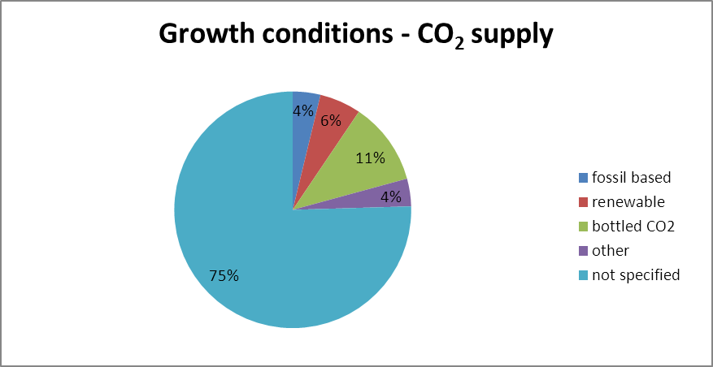
Figure 8: Growth conditions – CO₂ supply

As for the carbon dioxide supply, only very few information was received from the stakeholders. Most of the stakeholders, who answered this question, are using industrially bottled CO₂ (11 %, figure 8). Renewable carbon dioxide is mostly used when algae production is combined with a biogas plant in which CO₂ is produced as side product. Altogether 6 % of the questioned stakeholders use CO₂ from renewable resources. Only 4 % of stakeholders use either fossil based CO₂ for algae production or they used a carbon supply with does not fall in any of the categories such as atmospheric CO₂ or 13C labelled CO₂.

Markets
As in the section on algal cultivation conditions, it needs to be emphasized that multiple answers were permitted since most algae stakeholders aim for more than one single product respectively market sector. The results have been summarized in the bar charts figure 9, 10 and 11.
In order to determine the most promising market sectors for algae, the targeted products have also been grouped accordingly.

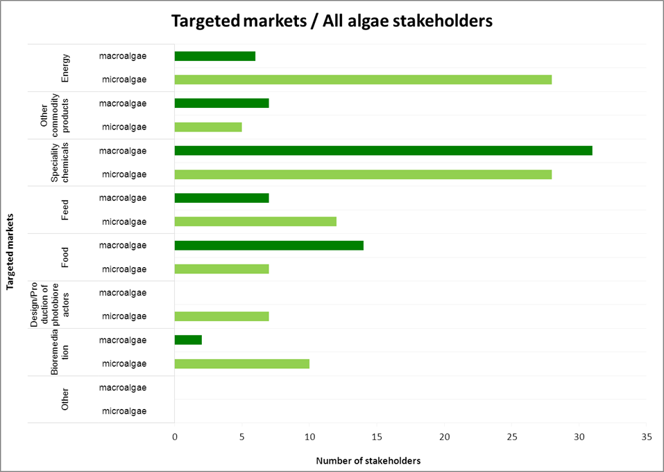
Figure 9: Targeted markets of the French algae stakeholders (multiple answers were permitted), separated according to macro- and micro-algae

The French algae stakeholders focus on specialty chemicals and food products mainly when using macro-algae (figure 9). Energy production, feed production and other commodity products play a minor role in the usage of macro-algae, with macro-algae for bioremediation being targeted to the least extend. As macro-algae typically is harvested wild or grown in open ponds (chapter IV, Cultivation facilities), the focus on the design and production of photobioreactors in not existing.
The most promising markets for micro-algae products are within the energy sector and, similar to the macro-algae field, the specialty chemicals. Micro-algae are also used for feed and bioremediation purposes and to a lesser extend targeted on the production of photobioreactors, for food purposes and other commodity products. The stakeholders dealing with micro-algae typically target more diverse markets than those dealing with macro-algae.
The focus of scientific and industrial stakeholders is slightly different. Research institutions address a wider variety of aspects connected with algae cultivation and downstream processing and address generally a wider array of markets than commercial stakeholders.
The majority of the cultivated algae in France is used for material purposes, like specialty chemical (cosmeceuticals, nutraceuticals, pharmaceuticals), food and feed and other commodity products (e.g. bio-plastics and fermentation products). Algae-based bioenergy is an important field of interest as well, but is currently only practiced to a small extend commercially. Algae production is still too expensive to successfully enter low cost and high tonnage markets like the one for bioenergy. However, strong research and development activities can be found in this area in France, particularly among the research institution (see figure 10).

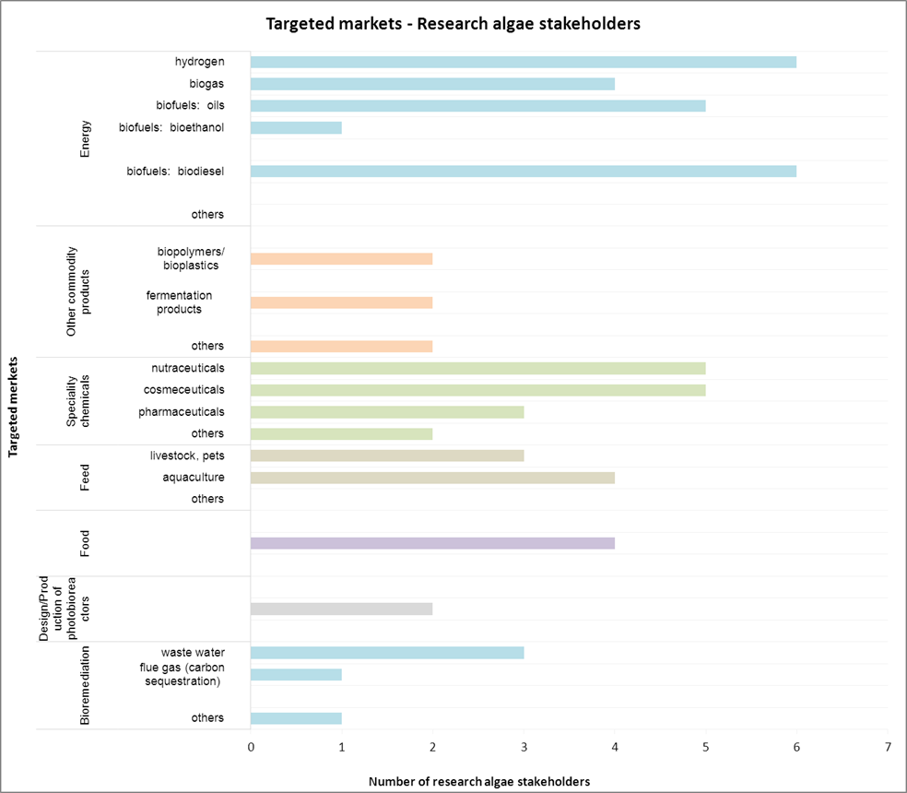
Figure 10: Targeted products of research institutions (multiple answers were permitted)

Beside typical biofuel products like biogas, oil, biodiesel and – to a small extend - bioethanol, six research institutions further examine alternative energy products like hydrogen (figure 10). This offers promising approaches, but seems currently to be still far from the market. Consequently, these pathways are mainly further developed in the context of research projects and are only pursued by few commercial stakeholders (figure 11).
In comparison with the research sector, bioenergy is a less important product for industrial stakeholders. This might however change, if more efficient production, harvesting and/ or processing methods will be established.
In regard to the different energy product targets, algae-based hydrogen and biodiesel appear to be the main products (figures 10 and 11).

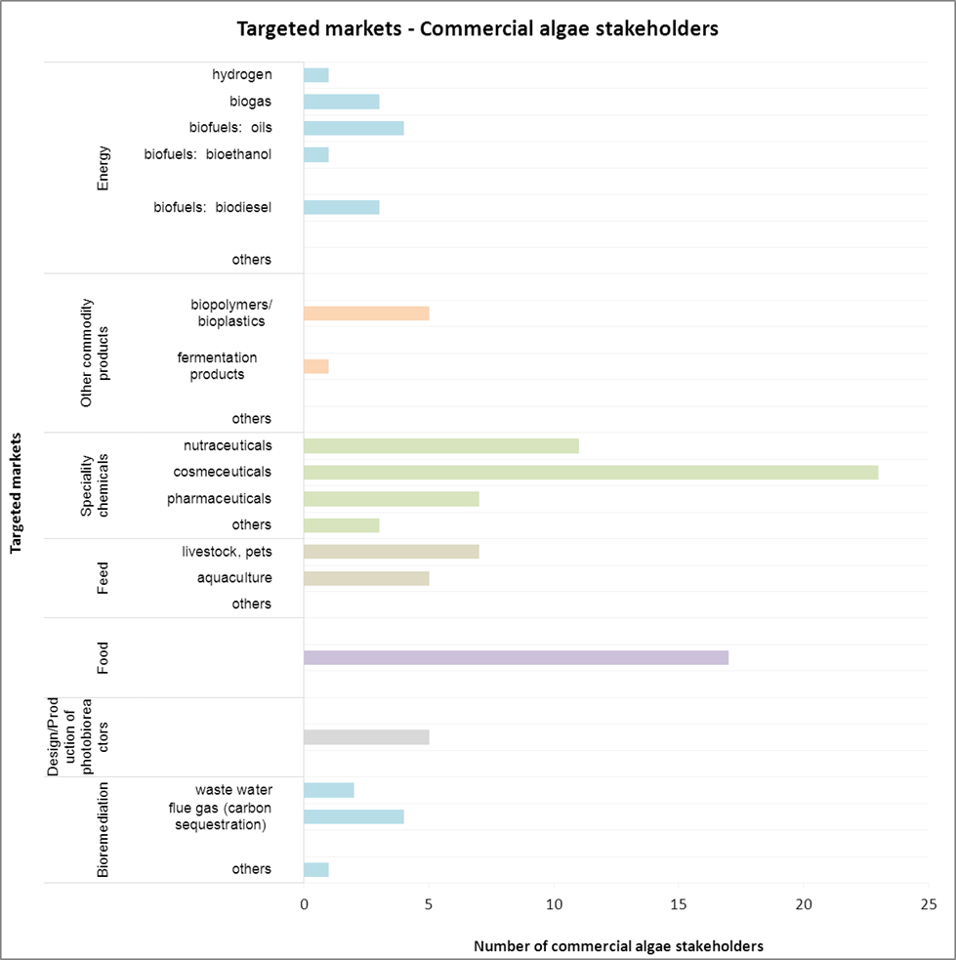
Figure 11: Targeted markets among industrial stakeholders (multiple answers were permitted)

For the industrial stakeholders, the market for specialty chemicals is, with a share of 43 %, the most important one. Especially cosmeceuticals and nutraceuticals play an important role in the French algae industry. In comparison, this market sector accounts for only 25 % of activity within research institutions (figures 10-11).
Another important market for commercial algae producers is the one for “food products”. Mainly macro-algae are used for human food production. For feed production (livestock as well as aquaculture), micro-algae play a bigger role.
The use of algae for other commodity products like bio-plastics and fermentation products account for only a minor share (industry: 6 %; research institutions: 10 %) in the total targeted markets for algae in France.
The targeted market for the design and production of photobioreactors is very low in France. Only 5 % of all commercial stakeholders and 3 % of the research stakeholders invest in this particular field.

Underpinning activities

Besides their main focus of activity, some of the stakeholders are also involved in actions supporting their efforts in further developing and improving their targeted products. About 45 % of the stakeholders provided information about research on environmental impacts or underpinning activities.
About 12 % of the commercial stakeholders are undertaking research on environmental impacts; the research stakeholders are more active in researching environmental impacts with a percentage of 33 %.

Modelling of environmental impacts and Life Cycle Analysis (LCA) is carried out by 10 % of all French algae stakeholders and thus seem to be the most important environmental research in the algae field in France. Whereas those two activities are the main activities carried out by commercial stakeholders, they were topped by research on abiotic interactions being carried out by research institutions (figure 13).

Biotic interactions was of interest to few stakeholders from both the commercial and research sides, whereas algal diseases and competitors where only researched by commercial algae stakeholders.
In regards to underpinning activities 33 % of all stakeholders carry these out. Here the amount of activity is quite the same between the commercial algae stakeholders and the research stakeholders. Most of the stakeholders, who carry out underpinning activities, are interested in more than one of the activities mentioned in the questionnaire.
Figure 14 shows the underpinning activities, sorted after the type of algae (sorted in macro- and micro-algae).

Bioprospecting and research on valuable substances in algae was cited as an activity by a relatively small number of stakeholders, 11 % and 17 % of academic and industrial stakeholders respectively. Most of the questioned stakeholders seem to rather concentrate on the already well-known algae species, trying to optimize the cultivation, harvest and downstream processes and technology.

Genetical engineering for optimising algae (incl. cyanobacteria) plays currently only a minor role, which is probably due to the restricting legal framework in Germany. Nevertheless it is a topic for some of the concerned research institutions (7 %) as well as the industry (6 %) and might become more important in the future in the search for strategies for reducing production costs - particularly for the energy market.

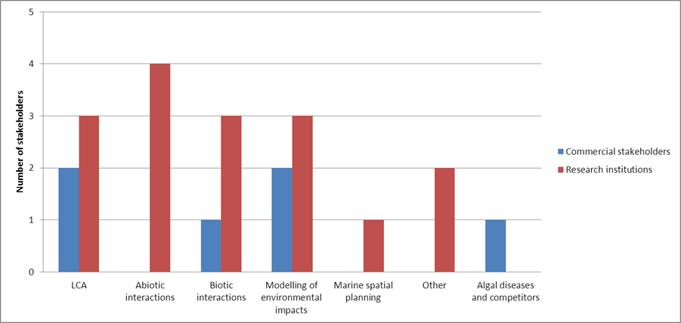
Figure 13: Number of commercial and research stakeholders involved in following activities relating to environmental impacts (multiple answers were permitted; total number of stakeholders: 48)

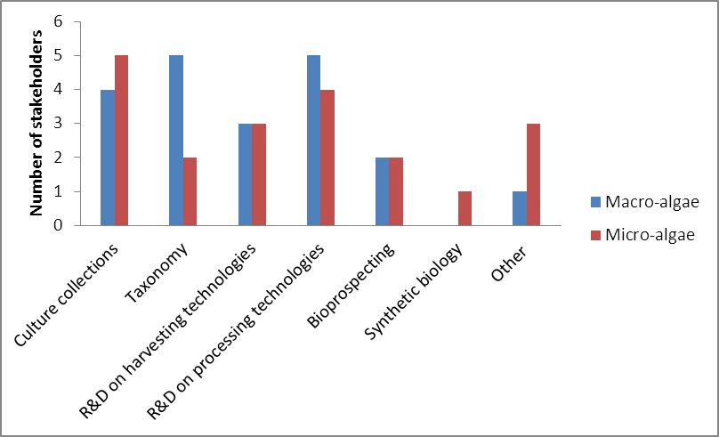
Figure 14: Number of stakeholders involved in following algae related underpinning activities (multiple answers were permitted; total number of stakeholders: 48), sorted after the used algae type

