**Energetic Algae (‘EnAlgae’)**

Project no. 215G

**Public Output**

OutputWP2A09.03 – Report on the state of algae related research and industrial activities in Belgium

**Authors**

Mona-Maria Brinker, Agency for Renewable Resources (FNR e.V.)

*Please cite this document as follows:*

Brinker, M.-M. 2014. Report on the state of algae related research and industrial activities in Belgium. Public Output report of the EnAlgae project, Swansea, [month and year of release], [number of pages]pp, Available online at [website link].

*This document is an output from the Energetic Algae (‘EnAlgae’) project, which has received European Regional Development Funding through the INTERREG IVB NWE programme.*

*© EnAlgae project partnership, [date of release], all rights reserved.*

Report on the state of algae related research and industrial activities in Belgium

Contents

1 Introduction 2

2 Belgian stakeholders 3

3 Types of algae 7

4 Cultivation facilities 9

5 Growth conditions 10

6 Markets 12

7 Underpinning activities 14

# Introduction

In 2012-2013 an inventory of North-West European algae initiatives was carried out to provide an impression of research and commercial activities connected to algae production and utilization. The collected data has been reviewed in country specific reports and collated and summarized in an overview report covering the whole North-West-Europe region (including Great Britain, Ireland, Germany, Belgium, France, Switzerland, Luxemburg and the Netherlands).

Data was obtained via a comprehensive questionnaire which was distributed among stakeholders identified in a preliminary scoping exercise. Not all questionnaires were filled out by the stakeholders and returned to the EnAlgae programme. In these cases, publically available information was used for the landscaping study. The questionnaire aimed to gather more information on focus, expertise and applied technology of the addressed institutions. It was also designed in a way that allows its use as an information sheet in EnAlgae’s web-based information portal and the Decision-Support-Tool (DST).

This report summarizes the results of the analysis of data collected in Belgium. For the purpose of clarity, the following analysis has been differentiated between research institutions and industrial enterprises.

It must be emphasized that this report cannot claim to reflect an exhaustive list of all stakeholders active in algae research and business. The reasons behind this are:

It is a rather broad area and in some cases only very limited information is available about respective activities. In addition, there is a lot of movement in the algae sector with regard to new start-ups and the closing down of business operations, making it difficult to maintain an up-to-date overview. If too little information could be found about certain institutions they were not included in this survey.

However, this study nevertheless represents the most important institutions active in the algae area, allowing conclusions to be drawn about the main fields of interests, technology and market opportunities for algal research in Belgium.

# Belgian stakeholders

In total 27 institutions working directly with algae could be identified in Belgium. The ratio of scientifically and commercially working stakeholders is equal. Table 1 gives an overview on the identified stakeholders, sub-divided into commercially active representatives and academic research oriented stakeholders. However it should be emphasized that some of these organizations work on the borderline between these two fields which make the separation by some means artificial.

Associations which are dealing with algae are not incorporated in the analysis of this report, but they are important algae stakeholders none the less.

The goal of the Flemish Algae Platform is to create a network for all Flemish organizations (companies, research institutions and associations) that currently have activities concerning micro algae or that would like to have activities with micro algae in the future. The network will facilitate and encourage the embedding of existing algae activities and the development of new micro algae related business activities.

The European Algae Biomass Association (EABA) is located in Brussels and aims to promote mutual interchange and cooperation in the field of biomass production and use, including biofuels uses and all other utilizations. It aims at creating, developing and maintaining solidarity and links between its members and at defending their interests at European and international level.

The European Biomass Industry Association (EUBIA) is also involved in algae activities, e.g. the EnAlgae project.

Table 1: Overview of Belgium stakeholders active in the broader algae area

|  |  |
| --- | --- |
| **Commercial stakeholders** | |
| Proviron | *Proviron* was established in 1977 as an engineering office, focusing on the development of new processes for environmental improvement. *Proviron* focuses on four branches of activities: specialty chemicals, biodiesel, custom manufacturing for third parties and algae. |
| Indaver | *Indaver* is a waste management company. It forms part of the Flemish Algae Platform. *Indaver* is studying how one can grow algae that feed on components of waste water (NOx) and flue gases (NOx and CO2) deriving from own processing installations. |
| CELABOR | *CELABOR* conducts private development and research on behalf of companies. Activities range from devising new methods of wastewater treatment: oxidation of pollutants, use of algae, etc. *CELABOR* is involved in the project Albaqua/Albapro which combines algal and bacterial waste water treatment for high environmental quality effluents. |
| BNLFood Investment S.A. (divisions Belovo - TLC The Lipid Company) | *BNLFoods* works on the extraction of phospholipids (omega 3/6 fatty acids). Currently mainly egg is used as a source, but algae biomass as a nutritional source for animal feed enrichment (for chickens to produce rich omega 3 eggs) and as an ingredient for extraction of phospholipid based omega 3/6 fatty acids directly from fermentation algae strains is researched. |
| AGROSTAR | *AGROSTAR* is one of the few European producers of microorganisms for environmental use. For the project FOTOBIOMAT *AGROSTAR* was the large-scale producer of algae. |
| Astrea | *Astrea* is involved in the treatment of complex industrial wastewaters, selling microalgae ponds for the treatment of nitrogen on older leachate containing little organic biodegradable matter. |
| ACP Belgium NV | *ACP* is a specialist in recycled and purified CO2. They are interested in new applications where the use of CO2 can play a role in algae projects. |
| Laborelec | *Laborelec* is a technical competence center in energy processes and energy use. The algae based activities are the identification of the most promising technologies / business with microalgae for GDF-SUEZ and third parties as well as integrated bio-remediation system coupled with energy production. |
| Flanders' Food | *Flanders’ Food* works on applications of microalgae in food and feed. |
| Alchemichfarmabvba | *Alchemichfarma* gives advice and consulting at pharmacies and medical companies on pharmaceutical raw materials and alternative energy. |
| VITO - Flemish Institute of Technological Research | *VITO* specializes in harvesting, medium recycle, biomass analysis and downstream processing of algae. In the Alchemis project a large-scale demonstration installation for algae biomass production in Flanders was built together with *Proviron* with use of CO2and NOx from waste gases and nutrients from wastewater. The e influence of contamination of the resources on the use of algal biomass was investigated and harvesting and medium recycle using membrane technology was investigated. The Sunbuilt is an EFRO investment project for the construction of closed algae PBR on pilot scale consisting of 4 tubular PBR’s, a harvesting and medium recycle installation and downstream processing equipment. This project is executed together with *Thomas More University Kempen* in Geel which is also the location of the installation. This installation will be operational in September 2014 (www.sunbuilt.be). In the FP7-miracles project *VITO* focusses on harvesting and medium recycle. In the FISCH Omega extract project *VITO* perform analytical work and work on extraction, downstream processing. We also have a PhD running for the development of a novel mild cell disruption method. *VITO* is also instigator and executor of the Flemish Algae Platform which promotes the algal industry in Flanders. |
| ECOVER | *ECOVER* produces ecological and sustainable laundry powder, washing-up liquid and soaps. Starting in 2014 they will use algal oil for its laundry liquid. The oil will be obtained from Brazil at the start. Aim is, however, to source it from close to their production plant. |
| SynCap | *SynCap* is involved in the production of bio-energy (diesel) from microalgae and Molecules with high added value. *Syncap* is the initiator of the BEMA project, and acts as financial advisor for the consortium. |
| **Scientific Stakeholders** | |
| RENUWAL | Recycling Nutrients from Wastewater using Algae |
| UniversitéCatholique de Louvain, Louvain-la-Neuve, Belgium | The University is doing baseline research on algae. It is involved in the projects BEMA (Bio Energy from Micro Algae), PHOTOFUNDS (Photosynthetic biorefineries - fundamental principles), BAMMBO (Biologically Active Molecules of Marine Based Origin), FOTOBIOMAT. |
| AGC Glass Europe; Carmeuse Research & Technology; Carmeuse | QGC Glass Europe focuses on CO2 capture + energy production |
| Ghent University, Bio-engineering Faculty, Campus Kortrijk | The bio-engineering faculty, Campus Kortrijk of Ghent University is involved in several algae research projects: PhD van den Hende: MaB-flocs for environmental technology Vervaeren: Feasibility of wastewater treatment with algae EnAlgae (wastewater treatment with microalgal bacterial flocks and conversion of harvested MaB-flocks to biogas via anaerobic digestion. |
| University Hasselt, Environemental Economics | Participating in applied and fundamental research on the biological, economic and legal aspects of environmental issues. Core specializations: Effects of (a)biotic stress factors at different biological organisation levels, from molecular to ecosystem level. Remediation and management of contaminated solid & renewable energy production. Policy supporting environmental research. |
| Karel de Grote Hogeschool | Goal: Optimal production, characterization and utilization of Single Cell Oils (SCOS) from algae and yeasts. |
| Universitè de Mons | At the Université de Mons several research groups are involved in algae research: Biosys Cluster, Energy cluster, and research institute for energy. Fundamental research is carried out on microlagal growth and its optimization, as well as on PBR design and optimization and algal biofuels production. |
| Belgian Nuclear Research Centre SCK CEN | SCK CEN is involved in different algae research projects: It is responsible for the analysis of the culture supernatants (cytokines) as well as the study of DNA damage and potential radio protective effect of food additives derived from *Spirulina*, a cyanobacteria used in life support project for long manned mission. Cyanobacteria *Arthrospira sp.* (strain PCC 8005) has been selected as a food supplement and primary oxygen-producing organism in the MELiSSA loop. In order to assess the stability of its food quality in space environmental conditions, the sequencing of its genome was undertaken. Further annotation and analysis of this genome is conducted at *SCK•CEN*with the help of its partners. Also the genomic plasticity of this strain under environmental stresses is under investigation. SCK CEN is also involved with Cyanobacteria *Arthrospira sp.* (strain PCC 8005) has been selected as a potential food supplement and primary oxygen-producing organism in the ESA project MELiSSA (Micro-Ecological Life Support System Alternative), which is currently being developed as a bio-regenerative life support system for long term manned space flight. In order to assess the stability of its food quality in space environmental conditions, the sequencing of its genome was undertaken (MELGEN project). Further annotation and analysis of this genome is conducted at SCK•CEN with the help of its partners. Also the genomic plasticity of this strain under environmental stresses and space flight conditions is under investigation (ARTEMISS project). Specific attention is given to its response to and high resistance to ionizing radiation. SCK•CEN investigates also potential radio protective effect of food additives derived from '*Spirulina*', containing the *Arthrospiracyanobactium*. The phototrophic bacterium *Rhodospirillumrubrum* has been selected as anaerobic organic waste degrading organism in the MELiSSA system,.Further annotation and analysis of this genome is conducted at SCK•CEN with the help of its partners. Also the genomic plasticity of this strain under environmental stresses and space flight conditions is under investigation (MELGEN & BASE & MESSAGE project). Specific attention is given to its response to different carbon sources, artificial light, ionizing radiation, as well as it quorum sensing and biofilm properties, to optimise efficient cultivation in engineered photo bioreactors. SCK•CEN investigates also potential cholesterol lowering effects of feed additives derived from *Rhodospirillumrubrum* biomass. |
| University of Gent | The University of Gent is involved in several algae research projects: Methalgae (methanotropic bacteria and autotrophic microalgae); Sunlight (Lipid based, high value products and renewable energy from microalgae); nutrient recovery from wastewater by microalgae; model based analysis of microalgal kinetics and flocculation. |
| University of Antwerp | The University of Antwerp has several algae research project going on: Sustainable energy and air purification; Bio-template *silica titania* diatoms for gas phase; photocatalysis. |
| KU Leuven | KU Leuven is involved in several research projects on algae: Developing cost-efficient technologies for producing and processing algal biomass (the aim is to develop harvesting and extraction technologies for microalgae),  Wastewater treatment using microalgae: optimizing removal of P from wastewaters with a low total N:P ratio, *Indonesia’s aquatic biomass for global sustainable energy production (Agentschap NL) – 2011-2013* (the aim is to optimize production of *Spirulina*in a greenhouse in the Netherlands and outdoors in Indonesia), Novel bioproducts from microalgae: Integration of the production process from cultivation to harvesting and downstream processing, Ecophysiology of phyto- and zooplankton from alpine lakes of the Cajas National park (Ecuador) (the aim is to isolate microalgae from high-altitude lakes and screen the species for antioxidants and pharmaceutically active compounds, Optimization of the production of *Spirulina*on concentrated wastestreams, Microalgae as a novel source of antioxidants (emphasis on onpolyphenol antioxidants), RENUWAL (REcyclingNUtrients from Wastewater using Algae) 2012 -2013) Enrichment of eggs with Omega 3 fatty acids through microalgae, Insight in mechanisms to unlock omega-3 fatty acids from microalgae (“OMEGA EGG” and “OMEGA OIL”). |
| Thomas More Kempen – University and College | Research is performed both on labscale and in pilot photobioreactors and mainly focusses on optimizing the cultivation conditions to obtain a sustainable production process with high yield. The pilot photobioreactors are installed in a greenhouse with an elaborate climate control system so that possibilities of the cultivation of microalgae as innovative activity for the horticulture can be examined.  Moreover research is performed to enhance the economic feasibility and sustainability of the production process. The photobioreactors are equipped with specialized measuring devices so that they are well suited for research purposes. Involvement in following projects:   * SUNBUILT – EU-funded EFRO (www.sunbuilt.be)   Several closed photobioreactors were built and installed in a greenhouse. The production units are coupled to a harvest and downstream processing unit for the extraction of high quality products that find their outlet in food, feed, aquaculture, cosmetics and pharmacy.  Partner: Flemish Institute for Technological Research (VITO)   * MIRACLES – EU-funded FP7 project (www.miraclesproject.eu)   The MIRACLES consortium consists of 26 partners and aims at developing integrated, multiple-product biorefinery technologies for the production of specialties from microalgae for application in food, aquaculture and non-food products. The research of Thomas More concentrates on medium recycling in the production process to increase the sustainability of the cultivation process.   * Enoptima – Thomas More funded PWO project (Practical Scientific Research project)   The energy issue in the cultivation of microalgae is investigated. The goal is to obtain a model that determines the most favorable cost (energy)/benefit (biomass) ratio, as a function of a wide range of environmental conditions. |
| Université de Liège | The University of Liège has several research projects on algae: Sunbiopath: improving sunlight capture and its conversion into biomass by microalgae (closed down). Photosynthesis optimization and production of hydrogen from *Chlamydomonasreinhardtii*Optimization *Heamatococcuspluvalis* medium. |
| Uni Namur, FacultésUniversitaires Notre-Dame de la Paix | Involved in algae research project: Fotobiomat: Bioencapsulation of photosynthetic micro-organisms - Biofuels from immobilised cells |

# Types of algae

A majority of 92 % of stakeholders work with micro-algae in Belgium, only eight percent claim to work with both micro- and macro-algae. No stakeholder working exclusively with macro-algae was recorded.

52% of the stakeholders provided information about the algae species, on a varying degree of accuracy (ranging from answers like ‘fresh water algae’ to species names). 66% of all stakeholders are using green algae and 15% diatoms (figure 1). Overall, the use of algae types varies significantly, with a few species (i.e. *Chlorella*) being used slightly more than others (figure 2).

Based on the provided data, a considerable amount of stakeholders, work with cyanobacteria (16%). One organization uses alphaproteobacteria. Although these cyanobacteria are not algae from a scientific perspective, they are often mentioned in the context of algal activities.

There is no significant difference between the algae types used by commercial and scientific institutions.

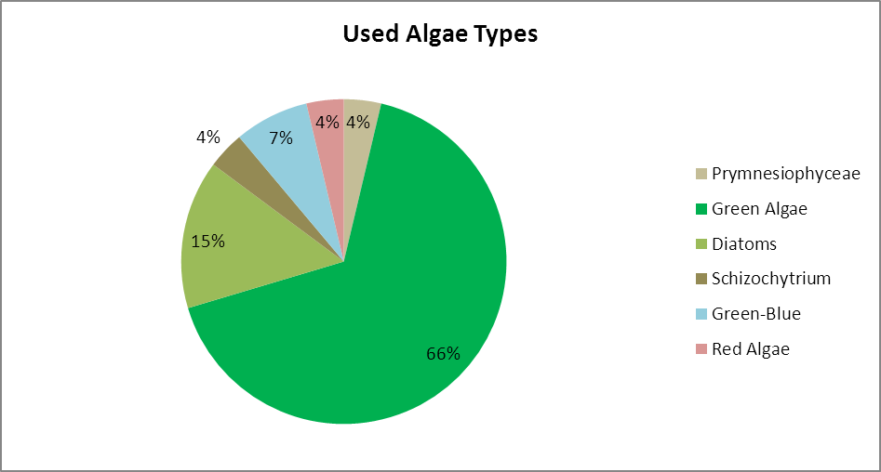

Figure 1: Used algae types in Belgium

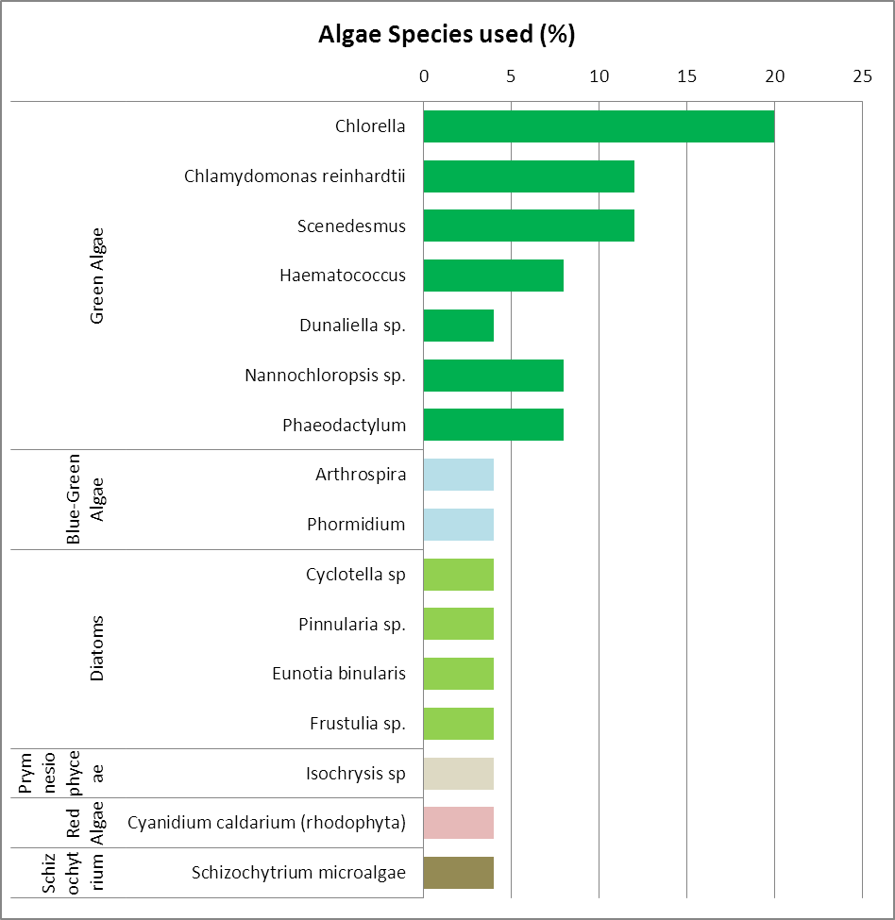

Figure 2: Percentage of institutions working with these algae species (multiple answers permitted)

# Cultivation facilities

Over the last decade, constant and innovative research and development has been taking place in the area of algae cultivation technology. The presently used cultivation systems can be subdivided into open/half-open and closed photobioreactor systems (table 2).

Closed cultivation systems have the advantage of better controlling the cultivation conditions and, consequently, to guarantee the best temperature and light regime under almost sterile conditions.

Table 2: Cultivation systems

|  |
| --- |
| **Open/ Half-open production systems** |
| * Open-Ponds * Race-Way-Ponds * Longlines |
| **Closed photobioreactor systems (PBR)** |
| * Flat bed/ Plate/ Flat panel reactor * Tubular reactor * Bag/ Flexible tube reactor * Rain creating stack system („Horizon“) * Fermentation vessel (heterotrophic cultivation) |

Closed photobioreactors (PBRs) are the most favoured facilities for cultivating algae in Belgian research institutions. The most common PBR-systems are tubular reactors followed by fermentation vessels, flat panel bioreactors and plastic bags. It should be emphasized that there are a lot of different facilities mentioned which did not belong to the default types. To name a few respondents use ProviAPT aerated flat plastic panels and some limit their algae cultivation on laboratory scale batches.

Among the commercial organizations the allocation of the different cultivation facilities is almost even. Again PBR are slightly favoured before open facilities.

Wild harvest or flexible structures did not contribute to research or commercial algae activities in Belgium. Both industry and research institutions have a strong interest in constantly improving their algae cultivation systems or, respectively, to develop or test new ones which is reflected by the number of institutions working with ‘other’ cultivation facilities.

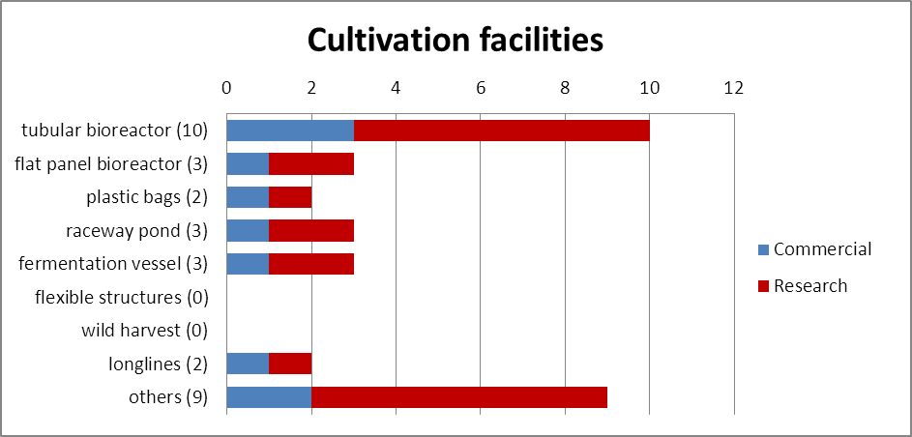

Figure 3: Cultivation facilities at research and commercial institutions (see total number in brackets behind the facility type. Multiple answers permitted)

We have received too little information on the size of the cultivation facilities or the volume of algae cultures. 15 out of 25 organizations gave none or an ambiguous answer. While the return form the commercial site allows no reliable statement at all, it can be said that cultivation volumes in research institutions range from 600m3 to lab scale formats. Cultivation sides range from 20.000 m2 to a few square meters.

# Growth conditions

In respect to growth conditions, the survey did not go into too much detail, but rather concentrated on the origin of the three main substances: water, light and carbon dioxide. Multiple answers were possible. 28 % of the stakeholders provided no information about the conditions in their respective algae growth facilities. Especially we found a poor response rate from commercial institutions which might be due to their respective company confidentiality policy.

In regard to the growth medium, 9 stakeholders cultivate their algae in fresh water (36 %). 6 respondents grow algae in both fresh and salt water (24%). We found also a high percentage of stakeholders who make use of waste water for growing algae (36%). The waste water sources are quite different and comprise process waters (i.e. paper industry or farming) as well as municipal wastewaters.

There is no significant difference regarding the allocation between research and commercial institutions (figure 4).

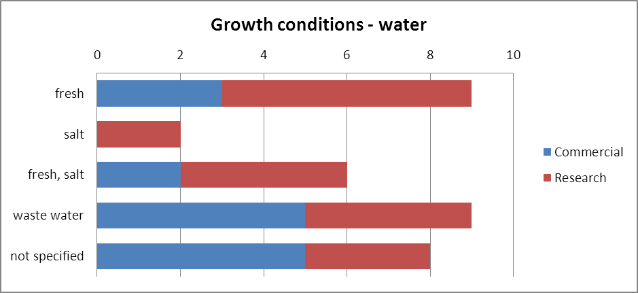

Figure 4: Growth condition – water

In terms of the light regime, the majority of the stakeholders, who provided information, use natural light for growing algae: 40 % of the stakeholders rely on the natural radiation whereas 24 % use artificial light as an option (figure 5). The high number of research institutions (28 %) using artificial light corresponds with the size of algae cultivation which often happens only on lab scale. Hence costs of artificial light are negligible. None of the stakeholders focus on heterotrophic microalgae production or do not use any light.

Again we have a high number of stakeholders, mostly from the commercial site which did not deliver information on their light regime.

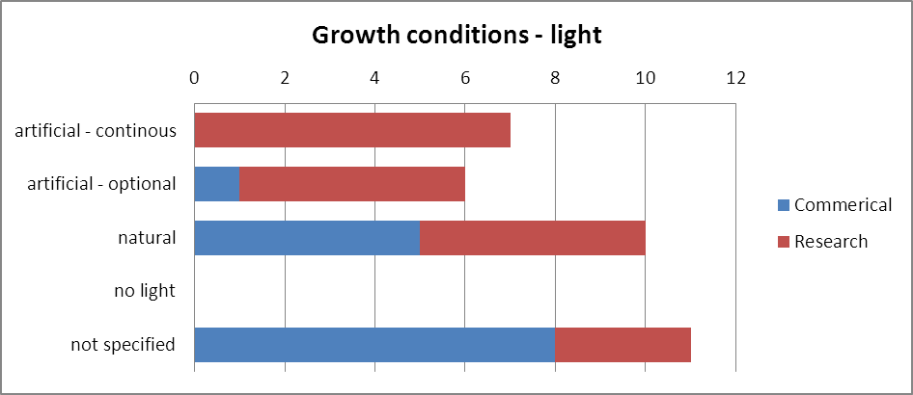

Figure 5: Growth condition – light

As for the carbon dioxide supply, only very few information was received from the stakeholders (figure 6). Renewable carbon dioxide is mostly used when algae production is combined with a biogas plant in which CO2 is produced as side product. Altogether 36 % of the stakeholders use this source. 16 % use fossil based CO2 from burning processes for algae production and 5 cross the ‘others’ option in the questionnaire. In this case they use flue gas or add carbonate to support algae growth. None of the stakeholders, who answered this question, use industrial bottled CO2.

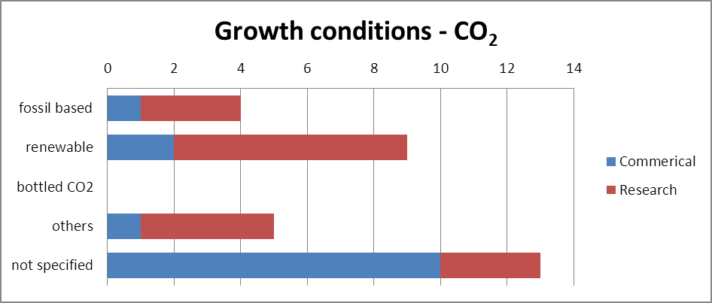

Figure 6: Growth conditions – CO2 supply

# Markets

As in the section on algal cultivation conditions, it needs to be emphasized that multiple answers were permitted since most algae stakeholders aim for more than one single product respectively market sector.

In order to determine the most promising market sectors for algae, the targeted products have also been grouped accordingly. Due to the low number of organizations participating in the survey insight is neglectable when presenting research and commercial institution shares in a detailed market chart (figure 7). A comparison demands a reduction of detail and will happen in a second graph (figure 8).

The Belgian algae stakeholders focus on specialty chemicals and food products mainly when using macro-algae. Macro algae were not used in energy production and bioremediation. As macro-algae typically is harvested wild or grown in open ponds (chapter IV, cultivation facilities), the focus on the design and production of photobioreactors does also not exist.

Micro algae are of high importance within the bioremediation sector and in manufacturing processes of specialty chemicals. They are also very much present in the area of feed or energy production and when it comes to the production of photobioreactors.

The majority of the cultivated algae in Belgium are used for material purposes, like specialty chemical (cosmeceuticals, nutraceuticals and pharmaceuticals), food and feed and other commodity products (e.g. bioplastics and fermentation products). Algae-based bioenergy holds 20% of the total algae related market. Algae production is still too expensive to successfully enter low cost and high tonnage markets like the one for bioenergy. However, strong research and development activities can be found in this area (figure 8). In all the other markets there is no significant difference between research and commercial activities. If commercial or research institutions have a slightly higher share in a certain market it could be seen as more or less accidental.

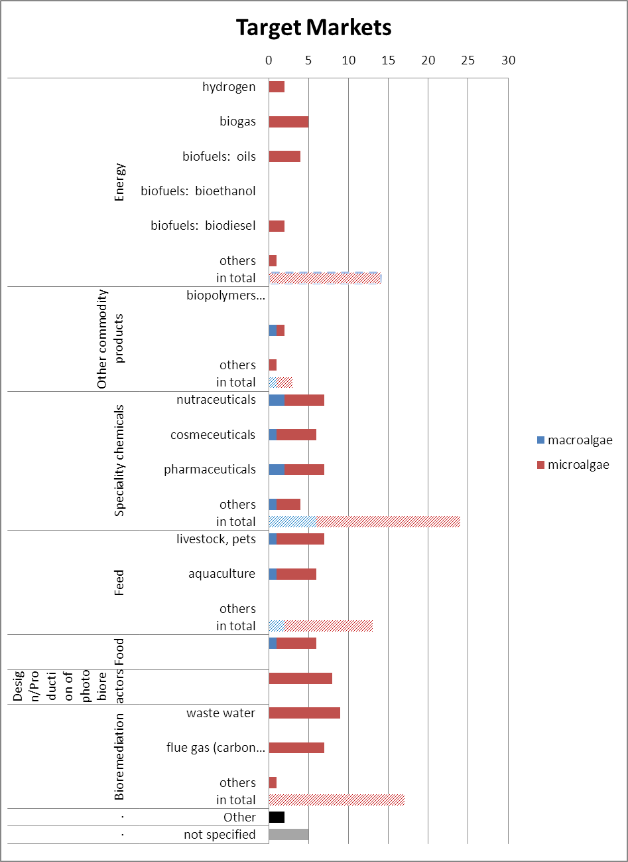

Figure 7: Targeted markets of the Belgian algae stakeholders (multiple answers were permitted), separated according to macro- and micro-algae

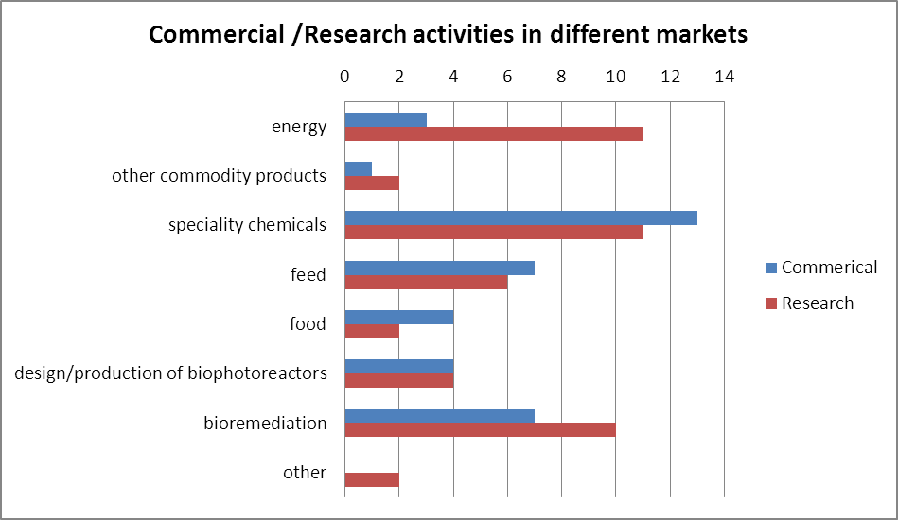

Figure 8: Targeted markets of research and commercial institutions (multiple answers were permitted)

# Underpinning activities

Besides their main focus of activity, some of the stakeholders are also involved in actions supporting their efforts in further developing and improving their targeted products. About 64 % of the stakeholders provided information about research on environmental impacts or underpinning activities. Macro algae play no role in these activities in Belgium thus we will not separate between micro and macro algae cultures (figure 9).

Only two commercial and four research institutions are conducting environmental research on algae. While the researchers focus on Life Cycle Analysis and biotic interactions business organizations work on models of environmental impact studies or abiotic interactions. None of the stakeholders researched on marine spatial planning and algal diseases. Due to the small number of organizations involved in environmental research there is reason to believe that this allocation is random.

60 % of the respondents are involved in underpinning activities. Most of the stakeholders who carry out these activities are interested in more than one aspect mentioned in the questionnaire. In total all options given are covered by the stakeholders with the highest participation in R&D on processing and harvesting technologies. There are a relatively high number of organizations which opted for ‘others’ as underpinning activity. They work on extraction technologies for phospholipids and omega-3/6 fatty acids; algal physiology and molecular biology, feasibility concepts and growth optimization to name a few.

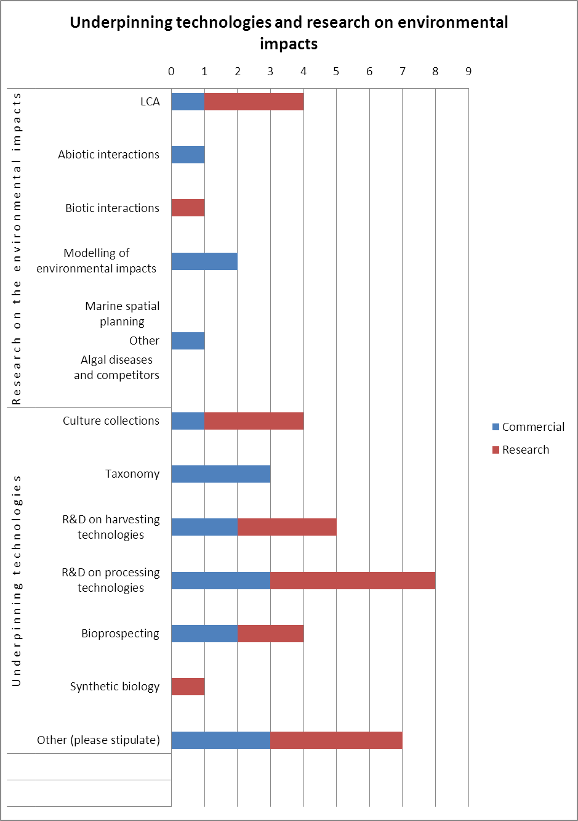

Figure 9: Number of commercial and research stakeholders involved in activities relating to environmental impacts or underpinning technologies (multiple answers were permitted)