**Energetic Algae (‘EnAlgae’)**

Project no. 215G

**Public Output**

Output WP2A09.04– Report on the state of algae related research and industrial activities in the Netherlands

**Authors**

Brinker, Mona-Maria, Agency for Renewable Resources (FNR e.V.)

*Please cite this document as follows:*

Brinker, M-M. 2014. Report on the state of algae related research and industrial activities in the Netherlands, Public Output report of the EnAlgae project, Swansea, [month and year of release], [number of pages]pp, Available online at [website link].

*This document is an output from the Energetic Algae (‘EnAlgae’) project, which has received European Regional Development Funding through the INTERREG IVB NWE programme.*

*© EnAlgae project partnership, [date of release], all rights reserved.*

Report on the state of algae related research and industrial activities in the Netherlands

Contents

1 Introduction 2

2 Dutch stakeholders 3

3 Types of algae 10

4 Cultivation facilities 12

5 Growth conditions 14

6 Markets 16

7 Underpinning activities and environmental impacts 18

# Introduction

In 2012-2014 an inventory of North-West European algae initiatives was carried out to provide an impression of research and commercial activities connected to algae production and utilization. The collected data has been reviewed in country specific reports and collated and summarised in an overview report covering the whole North-West-Europe region (including Great Britain, Ireland, Germany Belgium, France, Switzerland, Luxemburg and the Netherlands).

Data was obtained via a comprehensive questionnairewhich was distributed among stakeholders identified in a preliminary scoping exercise. Although not unexpected, unfortunately not all questionnaires were returned. In these cases, publically available information was used for the landscaping study and some additional information was collected through personal interviews with the respective stakeholders. The questionnaire aimed to gather more information on focus, expertise and applied technology of the addressed institutions. It was also designed in a way that as allows its use as an information sheet in EnAlgae’s web-based information portal.

This report summarises the results of the analysis of data collected in the Netherlands, where 40 % of the sent-out questionnaires were returned by the stakeholders. For the purpose of clarity, the following analysis has been differentiated between research institution and industry.

In this context it must be emphasized that this report cannot claim to reflect an exhaustive list of all stakeholders active in algae research and business. The reasons behind this are:

It is a rather broad area and in some cases only very limited information is available about respective activities. In addition, there is lots of movement in this sector with regard to new start-ups and the closing down of business operations, making it difficult to give an up-to-date overview. If too little information could be found about certain institutions they were not included in this survey.

However, this study nevertheless represents the most important institutions active in this area, allowing conclusions to be drawn about the main fields of interests, technology and market opportunities for algal research in the Netherlands.

# Dutch stakeholders

In total 51 institutions working with algae could be identified in the Netherlands. The majority of these stakeholders (65 %) are commercial algae stakeholders. The other stakeholders are from research institutions. It needs to be noted that most commercial algae stakeholders are also carrying out algae research and vice versa. This separation into the different types of stakeholders is based on the organization type of the organization mainly. Two regional water boards were also included in the research sector as they are not profit oriented as the commercial stakeholders. The following table (table 1) gives an overview about the identified stakeholders, sub-divided into commercially active representatives and academic research oriented stakeholders.

Table 1: Overview of Dutch stakeholders active in the broader algae area

|  |  |
| --- | --- |
| **Commercial stakeholders** | |
| AkzoNobel | AkzoNobel is the largest global paints and coatings company and is a leading producer of specialty chemicals. AkzoNobel is involved in the Algicoat project, hosting the demonstration units in Delfzijl since September 2008. |
| Algae Food & Fuel | Algae Food & Fuel designs, builds, sells and installs systems for the industrial and agricultural production of algae: algae farming. The use of innovative technologies for algae growth, process control and harvesting results in unique scalable systems which are cost efficient, highly productive and improve the stability of algae based processes. |
| Algaecom | Algaecom develops algae production sites. Cost and quality are Algaecoms key values. Therefore production is within the credentials of GMP+, HACCP and where possible under the SKAL label for biological products. These quality criteria are combined with robust yet affordable technology, so that our algae can be offered at a competitive price. The ambition of Algaecom is to operate production sites of 2 to 5 hectares, using residual heat and CO2 from flue gases produced by host companies. |
| Algaelink | AlgaeLink is a global leader in algae technology for 1. Pharma, 2. Food, 3. Feed, 4.Fuel, 5.CO2 sequestration and 6. Waste water treatment applications. A diversified range of 50 international projects has created the largest global network of algae cultivation projects. The fully automated AlgaeLink technology platform enables information exchange and fast learning curves. |
| AlgaSpring | AlgaSpring is a micro-algae biotech company focusing on nutrition, personal care and water treatment. AlgaSpring cooperates with specialized companies in feed, food and personal care for the development of products and sales. |
| Aquaphyto | AquaPhyto BV is an innovative company specialized in large scale production of micro-algal biomass. At Schiphol Airport, AquaPhyto owns an algae production unit for waste water treatment. Demonstration pond used to produce algae cultures for customers or for in-company research |
| Bioclear B.V. | To create innovative solutions that makes the world more sustainable using the power of nature: that is what Bioclear stands for. Bioclears aim is to construct a 10 acre pilot farm in the Eemshaven to create a unique possibility for hands on experience in the large-scale cultivation of micro-algae and other aquatic biomass like duckweed or Azolla. A business case is constructed utilizing power of scale, utilizing industrial waste streams (water, CO2, heat, nutrients) and by selling the protein-rich algae as feed. Bioclear is involved in the BioSolar cells project for which it co-develops techniques for maximum valorization of PUFA rich algae together with the University of Groningen and Algaecom |
| Crassus Advice4You B.V. | Crassus Advice4You helps companies to determine, develop and realize bio technology and innovative projects. Crassus Advice4You is involved in several national and international projects on algae growing on waste streams and algae coordinated along with biogas production units. Crassus is involved in the planning stages of these projects. |
| CreemersBioEnergie | The CBE (CreemersBioEnergie) companies are founded in 2008 with the aim of producing algae and processing algae to various green energy flows on a farm. |
| DSM | DSM is a life sciences company focusing on health, nutrition and materials. DSM is involved in the joint research project BioSolar Cells. DSM want to get insight in (im)possibilities of phototrophic algae. DSM sells Life’s DHA™ - a fish free, sustainable source of DHA omega- 3 from algae that provides important brain, eye and heart benefits throughout life and can be found in over 500 foods, beverages, infant formulas and supplements worldwide. |
| Essent | Essent is the Netherland's largest energy company. It was involved in the Algicoat project (Coating Components firing the Economic Biorefinery of Algae). Essent'stask in the project were to research the energy and CO2 aspects of the algae production, the conversion into biodiesel of the extracted biomass as well as other side streams (heat/electricity). |
| Evodos | Evodos is a company who specialized in separation technologies. Evodos has excellent results in harvesting algae. |
| Fargate | Fargate offers a concept to improve the sustainability profile of its customers by making use of their waste streams and reducing their emission. This evolved into the idea of making use of the waste streams warm water and CO2 as ingredients for producing algae. As production of algae is not the core business of its customers, they contacted algae-using companies to develop a market aligned with the specific needs and their preferred types of algae. Basically Fargate has three activities to organize for its business:  •Developing and selling installations  •Trading in algae  •Servicing the total business: e.g. maintenance |
| Hortimare | Hortimare is propagating seaweed for a sustainable future. Hortimare is involved in growing and cultivating seaweed. Hortimare has the vision to enhance the opportunities for the cultivation of seaweeds and offers high quality starting material. Various types of seaweed as young plants are available for experiments and commercial production. Hortimare delivers the fertilized gametophytes that just developed a small seaweed plant. This is attached to a carrier of choice so that it can be brought to grow in a tank or at the high sea. |
| ICOPAL | Icopal is Europe's leading manufacturer of products for the protection and waterproofing of building structures, particularly roofing and waterproofing membranes. Icopal has an algae pilot plant for the recycling of CO2 from a bitumen factory. |
| Kelstein | Kelstein is a company where three companies are linked with each other. The companies are dealing with dairy, biogas and algae growing.  This results in a closed chain of various streams: »Dairy farm »Biogas »Algae Cultivation working together in an innovative way to utilize residues that are common in farms. There has been developed a chain method in which the waste products used as raw material for the production of high biomass in the form of algae. |
| LansTomaten | Lans is a commercial tomato producer. Lans is involved in the research project "algae cultivation in horticulture" to make use of the synergies between plant and algae production in greenhouses. |
| LGem B.V. | LGem is an innovating company, active in the algae industry since 2005. The company’s motto: “LGem creates gems from light” easily explains the name of the company. In the early days LGem was founded on a propriety technology. In 2007 LGem started with a commercial scale production and sales of *Nannochloropsis*. This allowed them to validate and further improve their technology at a commercial scale. These valuable years of practical experience resulted in the development of GemTube systems equipped with the unique and patented Wavywind and Bubblebrush process. GemTubes ranging from 250—18,000 litres are now commercially available. The modular set up gives great flexibility in customizing unit sizes and dimensions, to client demands.  GemTubes are available for any need! |
| Maris Projects B.V. | The key activities from Maris Projects B.V. are processing waste to valued products. This has been Maris projects B.V. key activities for a long period. In the last years they gained experience especially in waste to bio-fuel and sub-products process. Maris Projects B.V. sells algae technology and grows algae. |
| Paques B.V. | Paques is a company focusing on biological wastewater and gas treatment. Paques is involved in the research project SPLASH and in the Algae Parc. Paques designs and builds various photobioreactors for microalgae production |
| Phycom | Phycom manufactures and markets essential nutrients for food, feed and pharma based on algae. Phycom selects the best algae strains and is able to make them axenic before cultivation starts. After succeeding the cultivation step, mass volume production of whole algae strains starts. This is realized by Phycom's algae production technology, which means production under the highest hygienic standards compliant with ISO 22000. |
| Phytocare | Phytocare is consulting company. They were involved in the algae research project "Algae cultivation systems for horticulture". Nowadays Phytocare consult Ecoferm. |
| Plankton Solutions | Focus on algae production on large scale. |
| Port of Rotterdam | The Port of Rotterdam’s focus in algae is on floating infrastructures due to a specific demand that the water level rises continuously during the operation of the Slufter (primarily used as a contaminated dredge-sludge landfill). Ultimately 260 ha will be available for algae farming. This is the single largest planned area for algae cultivation in the Netherlands. |
| PROCES-Groningen BV | Proces Groningen is involved in seaweed biorefinery; they have several projects on digesting micro-algae. |
| ProductschapTuinbouw | ProductschapTuinbow leads a project on "algae for horticulture". |
| RFE Renewable Fuel & Energy | RFE Renewable Fuel & Energy’s objective is developing, producing and trading of renewable fuel and energy, included import and export. RFE is also constructing a pilot project for the production of algae that are used in food and feed. |
| Roem van Yerseke | Roem van Yerseke has a wide range of shellfish, where in mussels, oysters and prawn play a central role. In addition to these core products, they also offer supplement products to complete the product scope. The nutrition of shellfish broodstock, larvae and spat, consists of several types of micro-algae. These algae are cultivated in a specially conditioned area. Roem van Yserke provides possibilities to purchase living micro-algae. |
| Royal HaskoningDHV | The company, headquartered in Amersfoort, the Netherlands, is one of Europe's leading project management, engineering and consultancy service providers, ranking globally in the top 10 of independently owned, non-listed companies and top 40 overall. Royal HaskoningDHV has more than 10 years of experience with the cultivation of algae and a lot of experience and expertise in waste water treatment are being combined in the HRAP system (also called Integrated Algae Pond Systems IAPS). |
| Van der Lans | Van der Lans is an independent importer and distributor of fresh fruit and vegetables. A pilot system in which the growth of algae is tested as an extra income for tomato growers, freely available space beneath tomato gutters is used to place the reactor. |
| ViskwekerijNeeltjeJans | A seafood producer (mussels). Algae are cultivated as feed source for mussels. |
| Waterstromen B.V. | Waterstromen B.V. is a waste water treatment company, focusing on water self-purification, including algae usage. |
| Wetsus | Wetsus, centre of excellence for sustainable water technology is a facilitating intermediary for trend-setting know-how development. Wetsus creates a unique environment and strategic cooperation for development of profitable and sustainable state of the art water treatment technology. Wetsus participates in several research projects dealing with algae, e.g. on the maximization of photosynthetic efficiency; on algal biofilms; on the optimization of lipid production in microalgae and on carbon dioxide supply in photobioreactors. |
| **Scientific Stakeholders** | |
| ECN | ECN is the largest energy research institute in the Netherlands. ECN is participating in two research projects cultivating seaweed in the North Sea. |
| HoogheemraadschapHollandsNoorderkwartier | The regional water board (HoogheemraadschapHollandsNoorderkwartier – HHNK) is a government body with its own democratically elected management board and independent tax system. A pilot study on the wastewater treatment plant (RZWI) Alkmaar was carried out in order to develop knowledge about the performance of algae in an open reactor under Dutch climate conditions. |
| NIOZ - Royal Netherlands Institute for Sea Research | NIOZ Royal Netherlands Institute for Sea Research is the National Oceanographic Institution of the Netherlands. The mission of NIOZ is to gain and communicate scientific knowledge on seas and oceans for the understanding and sustainability of our planet, and to facilitate and support marine research and education in The Netherlands and Europe. The department of marine microbiology investigates the origin and maintenance of microbial diversity and its role in the structure and function of marine ecosystems. They are involved in the research project InteSusAl, they also do research on the photobiology of pelagic and benthic microalgae and on the isolation, identification, cultivation, and preservation of microalgae. |
| Rijksuniversiteit Groningen, Ocean Ecosystems - Energy and Sustainability Research Institute Groningen (Faculty of Mathmatics and Natural Sciences) | The department of Ocean Ecosystems is carrying out a research project on algae for green chemicals: physiology and growth optimization of marine diatoms for production of Long Chain Poly Unsaturated Fatty Acids |
| Reijksuniversiteit Groningen, Plant Ecophysiology  - Centre for Ecological and Evolutionary Studies(Faculty of Mathematics and Natural Sciences) | The department of Plant Ecophysiology studies the interaction between plant and environment. The adaptive and stress responses of plants to changes in the environment can be molecular, biochemical, biophysical, physiological and/or developmental modifications. The analysis of plant responses from the molecular level up to the level of the intact plant allows a fully integrated understanding of the plant-environment interaction. In the past 7 years the responses to light, salinity, drought, air pollution, elevated CO2, UV, sulfur and nitrogen nutrition and the effect of temperature have been studied in integrated projects. One focus lies on the utilization of carbon by aquatic algae and plants. |
| StichtingZeeschelp - Research Institute for marine aquaculture | StichtingZeeschelp focuses on stimulating innovation in marine aquaculture. They are conducting their own research and provide facilities for research at the station for marine aquaculture. The focus of StichtingZeeschelp lies with marine aquaculture and marine ecology. |
| Stowa - Foundation for Applied Water Research | The foundation coordinates and commissions research on behalf of a large number of local water administrations. The bodies which contribute to the STOWA are the 26 water boards, the provinces and the Ministry of Transport, Public Works and Water Management. Stowa has been investigating effluent polishing with algae. |
| TNO (Dutch institute for applied sciences) | TNO is running an industrial consortium, named GAIA, together with algae producers and end-users of algae ingredients to focus on processing of algae biomass and make the application of algae ingredients feasible. TNO has important know-how in opening algae and separating ingredients like proteins, oil and carbohydrates energy-effectively on a lab scale. This know-how will be used for scaling up to an industrial pilot. Furthermore, a mobile algae biorefinery will be fully operational in Q2 2014. |
| Technical University Delft, Faculty of Applied Sciences | TU Delft scientists are researching how to grow ‘fat’ algae by creating an environment in which they have an advantage over other kinds. These surviving ‘fat’ algae store a high percentage of lipids that are extracted to create biofuels |
| Technical University Eindhoven - Department of mechanical engineering | The department of mechanical engineering of the Technical University Eindhoven is developing a lab-on-a-chip that functions as a compact robust tool for the fast screening, real-time monitoring, and initial classification of algae. |
| University of Twente - The green energy initiative | The green energy initiative of the University of Twente is involved in a project called Be2.0 in which (among others) joint research with WUR on fuel from algae. While WUR is working on the algae selection and growth, U Twente is working on developing a method to produce ‘algae-fuel’ on a large scale. |
| VrijeUniversiteit Amsterdam - Faculty of Sciences - Biophysics of Phoyosynthesis/Energy | The group has a long tradition in photosynthesis research. Presently, there is a strong and coherent focus on Solar Fuels, to be created in systems ranging from genetically engineered organisms and artificial/hybrids photosynthetic complexes. |
| Wageningen University and Research Centre - ACCRES | ACRRES is an acronym for Application Centre for Renewable REsources and is the national applied research centre for sustainable energy and green raw materials. The applied research centre is a joint effort of the Lelystad research institutes Applied Plant Research and the Animal Sciences Group, both part of Wageningen UR, and ENECO. ACRRES investigates the possibilities of algae as a new (agricultural) crop and also considers biorefinery of algae biomass, which occurs as a component in a number of projects. |
| Wageningen University and Research Centre - AlgaePARC | Wageningen University and Research Centre (WUR) has built AlgaePARC pilot facilities at the Wageningen Campus. The goal of AlgaePARC is to fill the gap between fundamental research on algae and full-scale algae production facilities. This will be done by setting up flexible pilot scale facilities to perform applied research and obtain direct practical experience. It is a joined initiative of BioProcess Engineering (Wageningen University) and Food & Biobased Research. The research themes vary from microalgae strain development to microalgae cultivation, microalgae biorefinery and microalgae products. |
| Wageningen University and Research Centre - Bioprocess Engineering | The Bioprocess Engineering Chair group teaches and develops new bio-based processes for production and bio-refinery of pharmaceuticals, healthy food ingredients, bulk chemicals and biofuels. The depratement is involved in the research projects "Algae Parc", "biosolar cells", "Fuel4Me", "Splash", "Algadisc" and many other algae research projects (both micro-and macro-algae). |
| Wageningen University and Research Centre -Food and Biobased products | Food & Biobased Research is part of Wageningen University & Research centre. Food & Biobased Research is involved in the production and harvesting of micro-algae as well as the development of algae-specific biorefinery technologies. Food & Biobased Research focuses on biorefinery concepts which use the entire crop and extract both proteins and sugars from seaweed, for instance. New biorefinery concepts for microalga e and seaweed are a current research topic at Food & Biobased Research.  It is involved in a research project on seaweed as source of biofuels and chemicals. A close cooperation with WURs AlgaePARC is given. |
| Wageningen University and Research Centre - IMARES | Imares is one of the research institutes of the Wageningen University. IMARES (Institute for Marine Resources and Ecosystem Studies) is the Netherlands research institute established to provide the scientific support that is essential for developing policies and innovation in respect of the marine environment, fishery activities, aquaculture and the maritime sector. At IMARES a report was conducted on the feasibility of sustainable offshore production of seaweed. IMARES also offers indoor and outdoor cultivation of algae. |
| WetterskipFryslan - Friesland Water Authority | Friesland Water Authority is a regional water board in the Netherlands. WetterskipFryslân is responsible for integrated water management in the province of Fryslân as well as a small part in the province of Groningen. |

# Types of algae

The majority of the stakeholders are working with microalgae. A relatively small proportion is cultivating and processing macroalgae or working on both macro and micro types (13 % of the industrial stakeholders and 38 % of the research institutions).

35 % of the concerned stakeholders provided information about the precise algae specie(s) they are using. The majority of these stakeholders are using green algae (59 %, figure 1). Overall, the most favoured species are *Chlorella sp*., *Scenedesmus sp*., *Nannochloropsisgaditana* and *Phaeodactylum sp*. (figure 2).

5 % of the Dutch stakeholders work with cyanobacteria. Although cyanobacteria are not algae from a scientific perspective, they are often mentioned in the context of micro-algal activities. Some of the stakeholders have focused on both microalgae and cyanobacteria. For this reason the work with cyanobacteria was also included in this overview.

Various species of macroalgae such as *Laminaria*, *Alariaesculenta* and *Latissimasaccharina*, account for 7 % of algae species under investigation in the Netherlands.

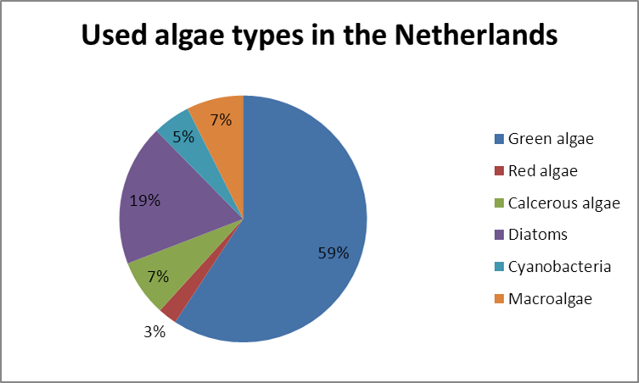

Figure 1: Used algae types in the Netherlands

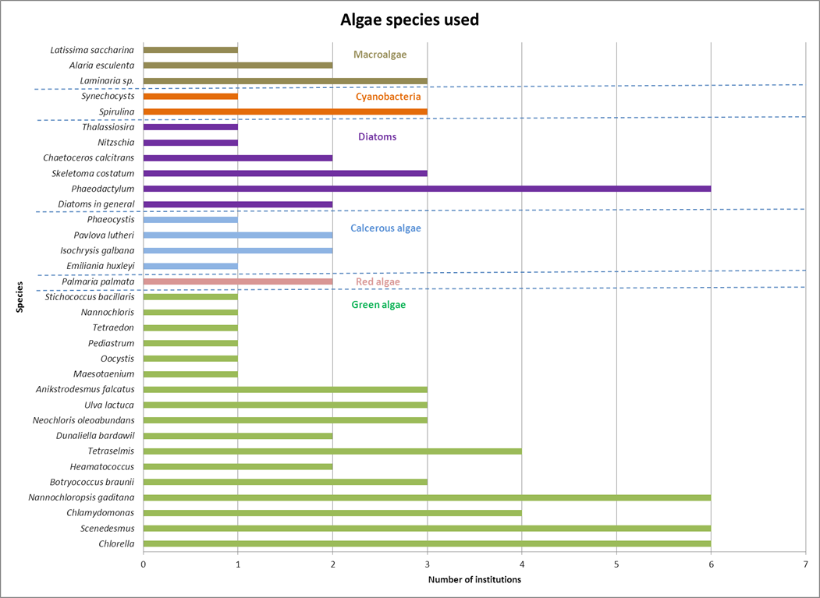

Figure 2: Number of institutions working with these algae species (multiple answers permitted)

# Cultivation facilities

Over the last decade, constant and innovative research and development has been taking place in the area of algae cultivation technology. The presently used cultivation systems can be subdivided into following systems:

Table 2: Cultivation systems

|  |
| --- |
| **Open/ Half-open production systems** |
| * Open-Ponds * Race-Way-Ponds * Longlines |
| **Closedphotobioreactorsystems (PBR)** |
| * Flat bed/ Plate/ Flat panel reactor * Tubular reactor * Bag/ Flexible tube reactor * Rain creating stack system („Horizon“) * Fermentation vessel (heterotrophiccultivation) |

Closed cultivation systems have the advantage of better controlling the cultivation conditions and, consequently, to guarantee the best temperature and light regime under almost sterile conditions.

Raceway ponds are the most favoured facilities for cultivating microalgae in both, industry and academia in the Netherlands. The most common closed photobioreator systems used in both commercial as well as research oriented institutions are tubular photobioreactors followed by plastic bags (figure 2 and figure 4). Many stakeholders run more than just one type of PBR.

Six of the research institutions and two of the commercial algae stakeholders have mentioned that they use “other” algae cultivation facilities. Those “other” algae cultivation facilities are often mentioned to be open ponds, LED photobioreactors or small scale laboratory flasks.

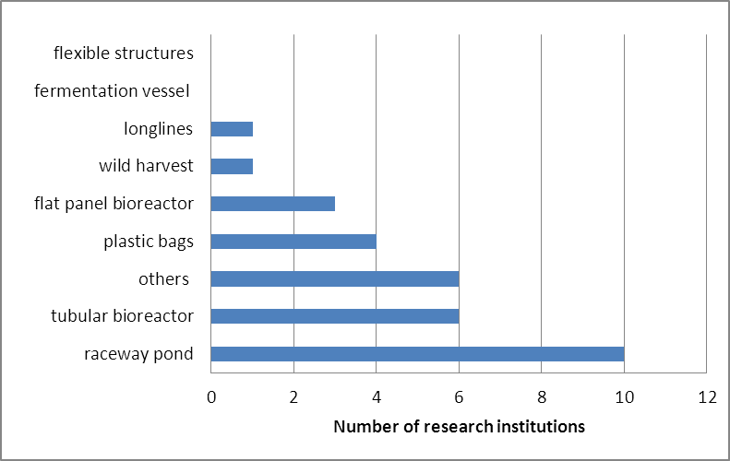

Figure 3: Cultivation facilities at research institutions

In regard to size of the facilities there are big differences between the different stakeholders. Some of the industrially used algae growth facilities comprise a volume of over 2500 m³, whereas some of the research institutions use facilities with less than 1 m³ capacity. It can be noted that generally the commercial algae producers have the bigger algae production facilities.

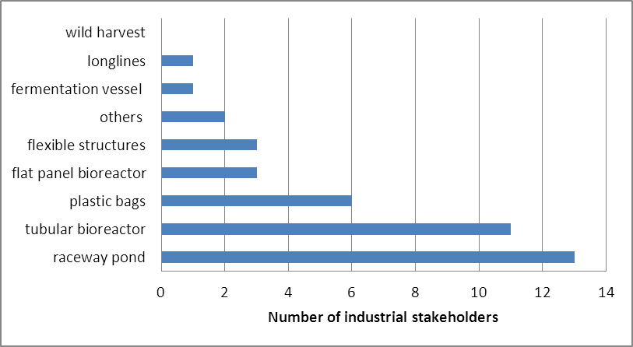

Figure 4: Cultivation facilities in industry

# Growth conditions

Approximately two-thirds of the Dutch algae stakeholders provided information about the conditions in their respective algae growth facilities. In respect to growth conditions, the survey did not go into too much detail, but rather concentrated on the origin of the three main substances: water, light and carbon dioxide. Multiple answers were possible.

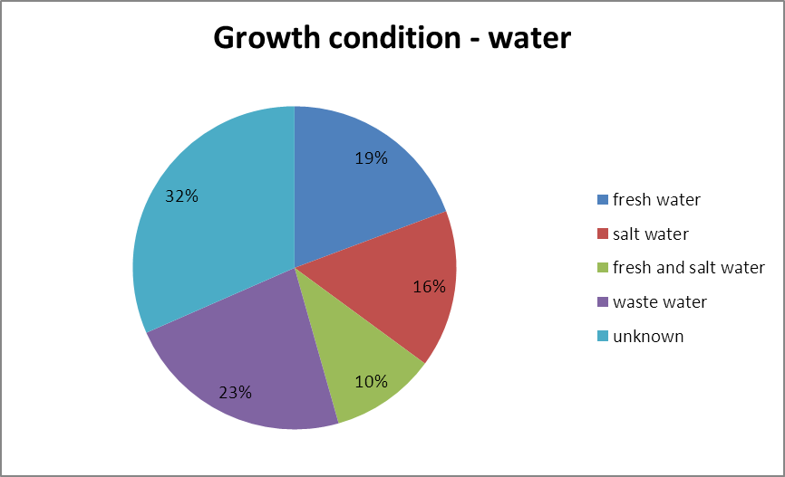

Figure 6: Growth condition - water

In regard to the growth medium, most of the stakeholders concentrate solely on either salt or fresh water species, the usage of both fresh and salt water for the cultivation of algae is only carried out at 10 % of the stakeholders. The use of fresh water slightly predominates when stakeholders are only focusing on one of the two mediums (figure 6).

Nearly a quarter of the stakeholders use waste water for algae cultivation. The waste water sources are not named too often but comprise effluents from biogas plants and agricultural wastewaters.

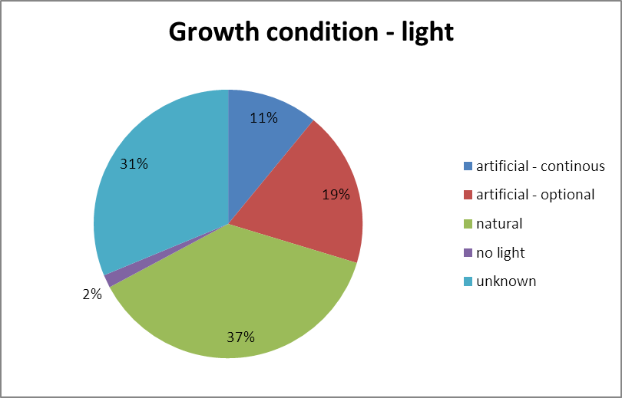

Figure 7: Growth condition - light

In terms of the light regime, the majority of the stakeholders, who provided respective information, use natural light for growing algae: 37 % solely rely on the natural radiation whereas 19 % of the stakeholders use artificial light when necessary (figure 7). Only 11 % of the stakeholders exclusively use artificial light for their algae cultivation. Only 2 % of the stakeholders have (also) focused on heterotrophic microalgae production and do not use any light.

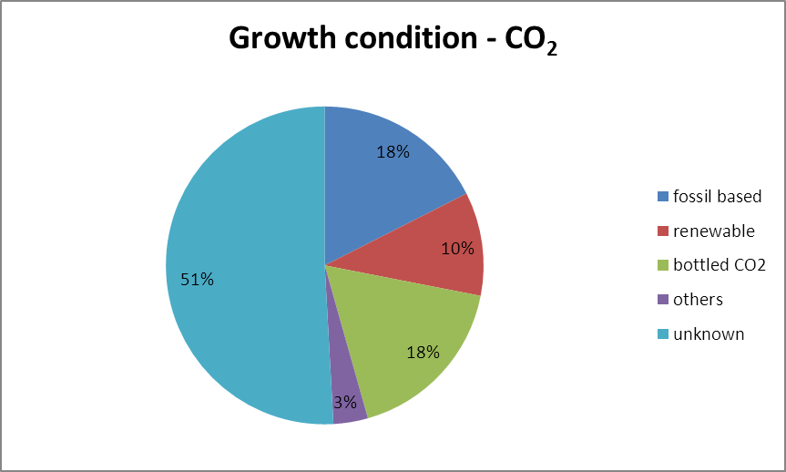

Figure 8: Growth conditions – CO2 supply

As for the carbon dioxide supply, most of the stakeholders are using industrially bottled CO2 or fossil based CO2 (both 18 %, figure 8). The stakeholders using fossil based CO2 have often installed their algae cultivation facilities close to heat or combined heat and power plants (CHP) and use the fossil based flue gas for algae production as a side product.

Renewable carbon dioxide is mostly used when algae production is combined with a biogas plant in which CO2 is produced as side product. In one case the flue gas from a heat plant based on wood is used. Altogether 10 % of the questioned stakeholders use CO2 from renewable resources.

# Markets

As in the section on algal cultivation conditions, it needs to be emphasized that multiple answers were permitted since most algae stakeholders aim for more than one single product respectively market sector. The results have been summarized in the bar charts figure 9 and 10. In order to determine the most promising market sectors for algae, the targeted products have also been grouped accordingly.

The markets for feed, energy and bioremediation are the most important targets for all Dutch stakeholders. Specialty chemicals and other commodity products also seem to play a bigger role, whereas the food sector and the production and design of photobioreactors seem to be of lesser importance to the Dutch algae stakeholders in general (figure 9).

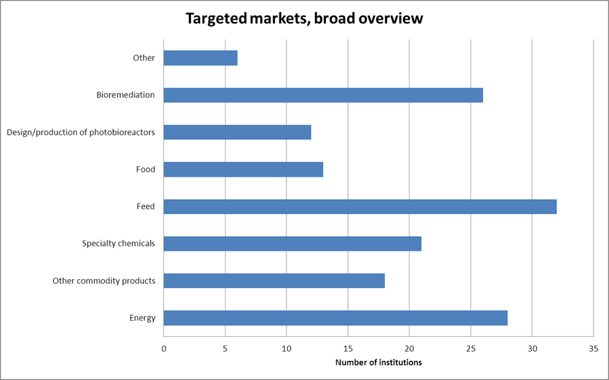

Figure 9: Broad overview of targeted markets of the Dutch algae stakeholders

When breaking the information down on the research versus commercial stakeholders (figure 10), and into the more precise target products, it is obvious that the most important markets for the commercial algae sector in the Netherlands are the feed sector (both for livestock and aquaculture) as well as wastewater remediation. In the total overview on the targeted markets, it seems that the design and production of photobioreactors is of little importance (figure 8). For the commercial algae sector though, the design and production of photobioreactors is of big importance, the research sector though does not focus much on it (figure 9).

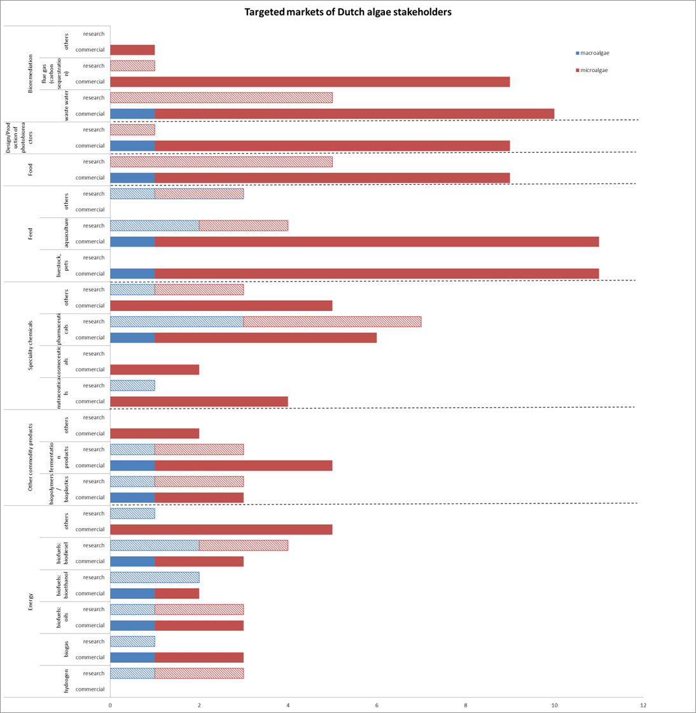

Figure 9: Targeted markets of Dutch algae stakeholders (x-axis= number of institutions targeting the specific market)

Beside typical biofuel products like biogas, oil, bioethanol, biodiesel and kerosene, some research institutions further examine alternative energy products like hydrogen (figure 9). This offers promising approaches, but seems currently to be still too far from the market. Consequently, these pathways are mainly further developed in the context of research projects and are not yet pursued by commercial stakeholders.

In comparison with the research sector, bioenergy is as an important product for industrial stakeholders in the Netherlands.

# Underpinning activities and environmental impacts

Besides their main focus of activity, most of the stakeholders are also involved in actions supporting their efforts in further developing and improving their targeted products. About 72 % of the research stakeholders and 37 % of the commercial algae stakeholders in the Netherlands provided information about these underpinning activities.

The majority of industrial stakeholders (47 % in total; figure 10) are investigating in new or further developing approaches for harvesting and processing algae biomass. R&D on processing technology is also the main interest of the research institutions with 50 % of the research stakeholders involved. A further 33 % of research institutions and 16 % of commercial stakeholders carry out “other” underpinning activities, involving activities such as R&D on production technologies, recirculation techniques or genetic engineering of algae.

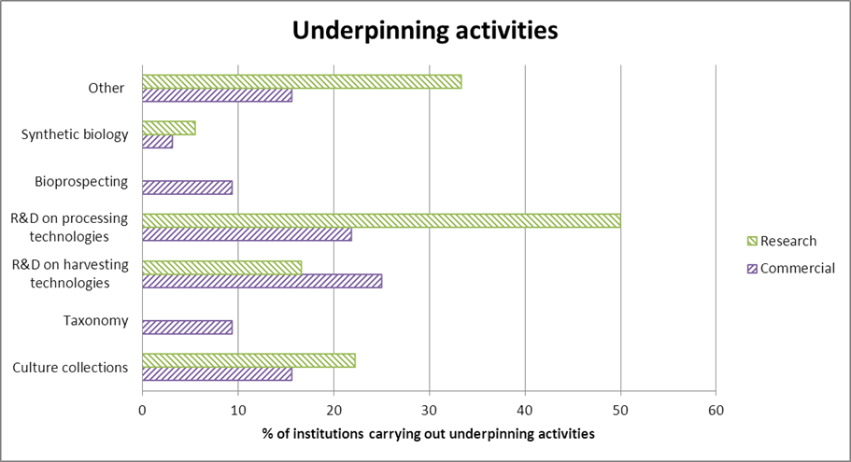

Figure 10: Number of stakeholders (in %) involved in following underpinning activities (multiple answers possible)

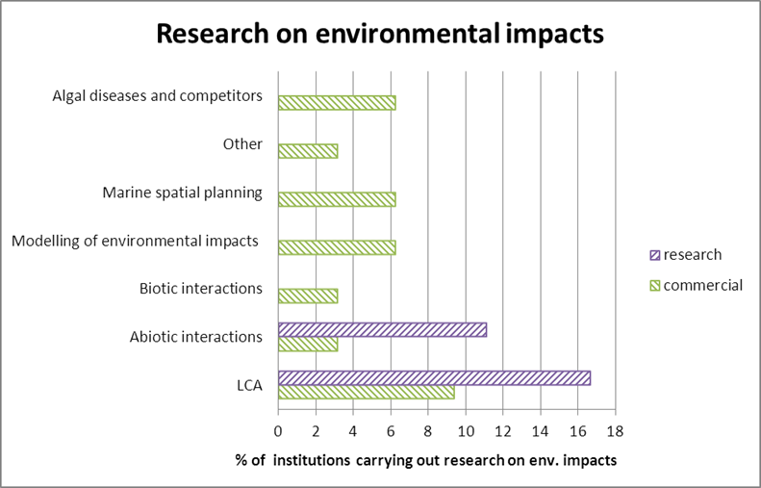

Figure 11: Number of stakeholders (in %) involved in research on environmental impacts (multiple answers were permitted)

Only 28 % of the research stakeholders and 16 % of the commercial stakeholders in the Netherlands are involved in research on environmental impacts.

Out of these few percent several of the stakeholders were dealing with different research on environmental impacts of algae production. The research institutions are mostly active in the LCA of the algae production and abiotic interaction, whereas the commercial interests on the research on environmental impacts are broader. LCA is also domination as activities of the commercial stakeholders, but the other aspects in this field seems to be of importance to the commercial stakeholders as well (figure 11).