Energetic Algae (‘EnAlgae’)

Project no. 215G

Public Output

WP2A09.01 – Report on the state of algae related research and industrial activities in Germany

Authors
Kristin Sternberg, Agency for Renewable Resources (FNR e.V.)

Please cite this document as follows:

Sternberg, K. 2014.Report on the state of algae related research and industrial activities in Germany, Public Output report of the EnAlgae project, Swansea, [month and year of release], [number of pages]pp, Available online at [website link].

This document is an output from the Energetic Algae (‘EnAlgae’) project, which has received European Regional Development Funding through the INTERREG IVB NWE programme.

© EnAlgae project partnership, [date of release], all rights reserved.

Report on the state of algae related research and industrial activities in Germany

Contents
1 Introduction 3
2 German stakeholders 4
3 Types of algae 10
4 Cultivation facilities 12
5 Growth conditions 14
6 Markets 15
7 Underpinning activities 19

Introduction
In 2012 an inventory of North-West European algae initiatives was carried out to provide an impression of research and commercial activities connected to algae production and utilization. The collected data has been reviewed in country specific reports and collated and summarised in an overview report covering the whole North-West-Europe region (including Great Britain, Ireland, Germany Belgium, France, Switzerland, Luxemburg and the Netherlands).
Data was obtained via a comprehensive questionnaire which was distributed among stakeholders identified in a preliminary scoping exercise. Although not unexpected, unfortunately not all questionnaires were returned. In these cases, publically available information was used for the landscaping study and some additional information was collected through personal interviews with the respective stakeholders. The questionnaire aimed to gather more information on focus, expertise and applied technology of the addressed institutions. It was also designed in a way that as allows its use as an information sheet in EnAlgae’s web-based information portal.
This report summarises the results of the analysis of data collected in Germany, where 62 % of the sent-out questionnaires were returned by the stakeholders. For the purpose of clarity, the following analysis has been differentiated between research institution and industry.
In this context it must be emphasized that this report cannot claim to reflect an exhaustive list of all stakeholders active in algae research and business. The reasons behind this are:
It is a rather broad area and in some cases only very limited information is available about respective activities. In addition, there is lots of movement in this sector with regard to new start-ups and the closing down of business operations, making it difficult to give an up-to-date overview. If too little information could be found about certain institutions they were not included in this survey.
However, this study nevertheless represents the most important institutions active in this area, allowing conclusions to be drawn about the main fields of interests, technology and market opportunities for algal research in Germany.

German stakeholders
In total 45 institutions working with algae could be identified in Germany. The majority of these stakeholders (60 %) are from research institutions. The other stakeholders are commercially oriented. The following table (table 1) gives an overview about the identified stakeholders, sub-divided into commercially active representatives and academic research oriented stakeholders.

Table 1: Overview of German stakeholders active in the broader algae area
Commercial stakeholders
Algomed - RoquetteKlötze GmbH & Co KG; | Production of Chlorella vulgaris for the food, cosmetics and pharmaceutical industry on large scale (600 m³, 500 km of tubes). Research also takes place on other algae species.  Roquette initiated its own research programme in 2008: “Algohub”. This project brings together 14 partners from research institutions and industry. It is the largest European programme for research on algae
Astaxa GmbH: cultivation of algae  Salata GmbH: sales and marketing of these algae | Company cultivates and sells (frozen or chilled) fresh and salt water microalgae for application in cosmetics and aquaculture.
BlueBioTech GmbH (since 2000); BlueBioTech International GmbH (since 2002) | Production of microalgae, commercialisation of own brand "BluBio"; offer collaboration with other companies in the value chain and contractual consulting.
bbi-biotech GmbH | Development and sale of innovative fermentors and bioreactors. The bbi-biotech GmbH offers equipment and services for all process applications within biotechnology, pharmaceutical, cosmetic and food industry.bbi-biotech has developed an own portfolio for standard bioreactor vessels as well as for disposable systems of 3rd party suppliers. The company is also offering equipment for heterotrophic production of algae as well as for high-quality phototrophic research approaches.
Clausthaler Umwelttechnik-Institut GmbH (CUTEC) | Focus on environmental and energy technology carrying out both research and development.
Algenol Biofuels Germany GmbH | Screening and (genetically) modifications of cyanobacteria for bioethanol production; after pre-selection in Germany the selected bacteria strains are entering pilot-scale testing at Algenol in Florida (outdoor in plastic tubes).
Cyano Biotech GmbH | Applied R&D on cyanobacteria; transferring know-how from academic research into an innovative biotech company; products and services comprise cultivation of different cyanobacterial strains from own collection (1500 strains) and from customer strains, harvest and freeze-drying of biomass, extraction and compound supply, cyanotoxins, analytical services.
GICON - Grossmann Ingenieur Consult GmbH | Biosolarzentrum: Project funded by Ministry of Economics of the State Saxony-Anhalt (430000 €) and GICON (planned investment: 12 Mill. € into algae-biofuel); Start: March 2011.  Development and operation of a new PBR (flexible tubular system).
GMB GmbH (associate of Vattenfall) | Project “green Mission”, funded by the European Union and the state Brandenburg focused on CO2 reduction in flue gases by means of algae and was finished in 2012. In 2013, the new project “greenVISION” started in Senftenberg: a pilot plant consisting of “Flat panel airlift” and “Hanging gardens” PBRs (the latter with 55000 l volume) are attached to a combined heat and power plant (GMB GmbH, Vattenfall); aim is to identify carbon capture and storage strategies using microalgae and to investigate the feasibility of a substantial use of CO2 to produce new biomass from microalgae for material use
IGV GmbH | Development and construction of PBRs (1-4 plants/ year); testing of different algae species; looking for active ingredients and accumulation of certain substances in microalgae.
MaRenate | Use of algae for bioremediation (absorbtion of nitrate, ammonium)  Research on algae fouling processes; biocide-free anti-fouling systems  Coordination of project "NaMaRo": Use of renewable marine resources (makro algae that were washed ashore at the North Sea + residues from fishing) for bioenergy production (biogas production and CH4 separation). Additionally plastic residues were separated and further processed.
NOVAgreen GmbH | Production and commercialisation of algae.  Development and use of tubular plastic bags and raceway ponds in green houses.  Combination with specially developed photovoltaic panels on roof of green houses
Phytolutions GmbH | Production and sale of foil/film bioreactors (tubular plastic bags)for outdoor use; development of an algae harvesting machine;  R&D in harvesting and processing technology.
Phyton Energy GmbH | Development of a new PBR (patent pending ); Goal: biodiesel from algae  In planning stage: production of algae in closed plastic mattresses in North Germany and in open ponds in South Africa; Aim: sale of biomass, extracted oil or biodiesel.
Strategic Science Consult GmbH (SSC) | Development of thermally isolated (plate-) PBR for use as building element for facades. Integration of microalgae process technology into building services. Mutagenesis of different species; focus: production of fatty acids with use of flue gas.
Subitec GmbH | Production and commercialisation of flat-panel airlift reactors  Pilot plants:  Cooperation with E.ON Hanse AG in Hamburg-Reitbrook; attached to a natural gas-driven heat and power plant (start: May 2008)  Cultivation System for microalgae for FairEnergie GmbH in Reutlingen; attached to natural gas-driven heat and power plant (start: July 2010)  Cooperation with GMB GmbH/ Vattenfall Europe Mining AG in Senftenberg; attached to a brown coal-driven heat and power plant (start: July 2010)
Südzucker AG/ CropEnergies | Partner in project "Biorefinery based on algae with increased starch content - use of starch and protein". Aim is the material and energetic use of algae biomass. The main ingredient, starch, will be used for ethanol production whereas for protein new utilisation pathways are being explored. Thus, the added value of the use of algae rich in carbohydrates should be increased. The biomass residues will then be used for biogas production. The selected algae will be produced in flat-panel-airlift reactors from the company Subitec. A respective pilot plant, comprising 24 photobioreactors at 180 l each, has been built on Crop Energies prodution site in Zeitz.  Production includes an online monitoring system, which will be tested in the process. The needed CO2 for algae biomass production is supposed to come from the ethanol fermentation process. Any remaining nutrients as well as water will be re-used for the algae production process.
SylterAlgenfarm - Marine Integrated Algal Aquaculture GmbH & Co KG | Breeds/ produces and sells macro-algae to food and cosmetic industry.
Verfahrenstechnik Schwedt GmbH (VTS) | Concept: continuous algae production using flue gas and recycled nutrients.  Extraction of algae lipids from wet biomass.  Refining of oil to biofuels.  Catalytic hydrogenation for added value in process chain.  Fermentation of remaining biomass.  Biogas plant as source for CO₂ and recycled nutrients.  Industrial partner (e.g. heat plant) for site and infrastructure; provision of flue gases, waste heat and H_{2.}  Use of H₂ from regional and renewable sources (wind power).
Scientific Stakeholders
Deutsches-Biomasseforschungs-Zentrum gemeinnützige GmbH | Post processing of algae biomass with focus on energetic use.
FraunhoferInsitute for Interfacial Engineering and Biotechnology (Fraunhofer IGB)  (Institute for contract research) | - Coordinates Project “Biorefinery based on carbohydrate-rich algae biomass; use of starch and proteins” (Dec. 2012 – Nov. 2015)  Aim is the material and energetic use of algae biomass. The main ingredient, starch, will be used for ethanol production whereas for protein new utilisation pathways are being explored. Thus, the added value of the use of algae rich in carbohydrates should be increased. The biomass residues will then be used for biogas production. The selected algae will be produced in flat-panel-airlift reactors from the company Subitec. Production includes an online monitoring system, which will be tested in the process. The needed CO2 for algae biomass production is supposed to come from the ethanol fermentation process. Any remaining nutrients as well as water will be re-used for the algae production process. Project partners: Subitec GmbH, Südzucker/ CropEnergies  - Project: "Integrated processes for the production of omega-3 EPA (eicosapentaenoic acid) in the FPA photobioreactor using microalgae, development of disintegration and extraction processes" (as cost effective alternative to EPA production from fish oil);  - Project: "EtaMax: More Biogas from waste and microalgae residual material through combined Bio-/Hydrothermal Gasification"; research on algal lipids in Chlorella vulgaris in 30 l FPA reactors with different nitrogen availability in a 2-stage repeated fed-batch and batch process. Closing circuits between anaerobic digestion of organic wastes to biogas and algae cultivation by using effluents from AD for microalgae cultivation. Research on using flue gas from power plants for algae production; digestion of residual biomass to biogas.  - Project: EcoBug: Development of an innovative industrial bio reacting and fermentation process producing an organic insect repellent-fertilizer for ecological farming. Process development for the production of filamentous cyanobacteria with insect repellent activity.  - FP7 project ProEcoWine: Development of a process to generate a novel plant protection product enriched with micronutrients to replace copper in organic viticulture. Task of Fraunhofer IGB is process development for the production of algae biomass with bioactivity against downey mildew (Plasmoparaviticola) and Botrytis cinerea infection on leaves and grapes.  - Study Factor 10: biorefinery concepts for micro algal biomass
Fraunhofer Institute for Environmental, Safety and Energy Technology (Fraunhofer UMSICHT) | Part of the EU-project AllGas:  plant in South-Spain; algae production in waste water; oil extraction from harvested algae biomass => for feed additives and biodiesel; residues of algae biomass gets fermented into biogas/methane.
Research Centre Jülich (FZ Jülich) | FZ Jülich coordinates, together with EADS, an algae research and pilot project (“AUFWIND”; 2013-2015 project phase 1) with 12 partners. In that context, the Algae-Science-Center has been established. Aim of the project is to compare 3 different photobioreactor systems under same conditions in terms of their productivity, economic feasibility and ecological aspects within the production chain of algae-based bio-kerosene. The suppliers of the different systems are Phytolutions, NOVAgreen and IGV.
Hochschule für Technik und Wirtschaft des Saarlandes (HTWdS) / University of Applied Science Saarland | Development of sensors for algae (ALSENS project, 2009, supported by HTWdS);  Recycling of nutrients in marine recirculation aquaculture systems (RAS) by integration and optimisation of algae biomass production; (LANDMARK project, 2010 -2013; supported by Deutsche BundesstiftungUmwelt (DBU) and the government of the Saarland, Germany)  Participation in the Northwest European network of algal pilot facilities in the INTERREG strategic initiative "EnAlgae" (2011- 2015).
Institute for Interfacial Engineering IGVT at the University of Stuttgart | Project: "Integrated processes for the production of omega-3 EPA (Eicosapentaenoic acid) in the photobioreactor using microalgae, development of disintegration and extraction processes", 2007-2009; funded by DBU with 440970 € (50%); coord.: Subitec GmbH; harvest, extraction and purification of algae oil by IGVT; EPA extraction with supercritical CO₂ by K.D. PharmaBexbach GmbH.
Jacobs University Bremen (private) | Was part of project connected to pilot plant of RWE in Niederaußem; testing of different algae species; optimising used species; development of new PBRs => spin off: Phytolution GmbH: further development of "Phytobags"; pilot plant connected to waste incineration plant.
SAG - Sammlung von Algenkulturen Göttingen (Spin-off ofuniversityof Göttingen) | SAG has one of the three largest algae culture collections in the world (2400 strains); provides culture material for research, teaching and biotechnology communities worldwide; primarily microalgae and cyanobacteria.
Technical University of Berlin | Development of a laboratory for microalgae; Goal: optimisation of microorganisms through genetically modifications and improvement of respective technology ; exchange of scientists; production of valuable products from algae.  Research project funded by German Research Association - DFG: research on ability of algae to fix heavy metal legacies in water => bioremediation; testing of 48 different algae species and cyanobacteria.
Technical University Hamburg-Harburg | Development of a concept for the efficient use of alternative energy biomass with a focus on microalgae.
Technical University of Applied Science Wildau | Pilot plant: PBR connected to a heat and power plant since May 2011 with funds of the State of Brandenburg.  Produced algae biomass is transformed/ fermented into biogas in a 2-stage process, which is used for power production in the connected heat and power plant; CO₂ produced in this process will again be used for the algae biomass production in the PBR.
Anhalt University of Applied Science | Cultivation of microalgae (up to 1200 l) and macro-algae (up to 10 l), testing of different species, algae reference stocks, testing of different processing techniques and uses for algae biomass  Bio Solar Centre - development of efficient technology using algae and solar energy (microalgae: cultivation of microalgae with high content of valuable products such as carotenoids, lipids and bioactive substances, macro-algae: single cell culture for production of bioactive substances).
University Bielefeld | Coordinator of project "Bio hydrogen production in microalgae" (2008-2011); funded by German Ministry for Education and Research: 1.8 Mill €; research on best conditions for hydrogen production; development of optimised PBR.
University of Applied Science Bremen | Project "AlgenBioGas" (2008-2011): development of new process for optimisation of biogas production in biogas plants = > removing CO₂ and hydrogen sulphide from biogas process chain by algae; use of algae biomass for value added product; building of pilot plant in cooperation with companies algatec and MT-Energie.  Project "AlgenKult": (2011-2014) Development of early warning systems for process stability in microalgae cultivation systems in open ponds; generation of guidelines for best practise for plant operators.
University of Duisburg-Essen (UDE) | Development and (lab-scale) testing of PBRs; research also on usage of thermophilic algae.
University Erlangen-Nürnberg | Bioactives, genetic engineering, reactor design.
University of Freiburg - Institute for Biology III | Takes part in the EU-project "DirectFuel" (Direct biological conversion of solar energy to volatile hydrocarbon fuels by engineered cyanobacteria); FP 7 fund: 3.7 Mill €); 2010-2014; coordinated by University of Turku, Finland.
Leibniz Universität Hannover | Research topics:  - Disposable photobioreactors for microalgae plant-Biotechnology.  - Biological degradation of antibiotics in municipal wastewater by microalgae or cyanobacteria.  - Photon Efficiency of microalgae bioreactors.  - Development of a 2-step bioreactor for the in-vitro production of PHB in Nostocmuscorum.  - Disposable culture systems for online monitoring of microalgae cultures.  - Production of high value compounds in microalgae.  - Agglutination signalling in microalgae.
University Kiel | Tests with digestate from biogas plant as culture medium for algae. Cooperation with Linde Group: research on hydrogen production using green algae.
HochschuleLausitz - University of Applied Science Lausitz | Part of the project SEMIRAMIS => cooperation partner of IGV GmbH; pilot plant.  Main task: screening of algae species, best growth conditions and R&D of PBR concepts.  New “HORIZON” - PBR concept; testing of components and culturing of microalgae in tubular reactor, harvesting of biomass and extraction and analysis of the important components in microalgae.
University Leipzig | Project 2011 - 2014: Development of a new process for production of biogas with algae"; funded by German Ministry for Education and Research: 1.5 M €.; partnership with University of Bremen and Karlsruhe
University Münster | Took part in project "Bio hydrogen production in microalgae" (2008-2011); funded by German Ministry for Education and Research: 1.8 Mill €; research on best conditions for hydrogen production; development of optimised PBR.  SUNBIOPATH: “Towards a better sunlight to biomass conversion efficiency in microalgae” (EU FP7/ 2010-2012, GA245070).  ALGALGLYCO: “A new scenario for the production of recombinant proteins in algae. Exploiting a native pathway for targeting glycoproteins to the algal chloroplast.” (Plant KBBE-0315453, 2009-2012).  SPLASH: “Sustainable PoLymers from Algae Sugars and Hydrocarbons” (EU FP7/ 2012-2016).
University of Applied Sciences Ostwestfalen-Lippe | Development of innovative lighting- and reactor systems for the production of algae based cosmetic ingredients.
Bauhaus Universität Weimar | Modelling and design of a photobioreactor for macroalgae;  Culture collection;  Research on processing technologies
Ruhr-Universität Bochum | Biogas from the marine microalgae Nannochloropsissalina in mono-digestion compared to typical energy crops; influence of different physical pre-treatment methods and the content of salt on biogas production; co-digestion of microalgae and energy crops (maize silage, CCM) in batch and continuously fed plants; energetic and economic analysis of pre-treatment; ecologic analysis of biogas production from microalgae compared to maize silage.
KIT (Karlsruhe Institute of Technology) Institute of Process Engineering in Life Sciences Department of Bioprocess Engineering | Integrated bioprocess and photobioreactor development  "KIT Algae Platform" was founded in 2009; objectives: development, integration and analysis of all process steps required to use algae biomass for energy production; including reactor development for algae cultivation , conditioning of algae, energy production from algae, system analysis and sustainability assessment  Following institutes are involved:  Institute of Process Engineering in Life Sciences  Institute for Pulsed Power and Microwave Technology  Institute for Technology Assessment and Systems Analysis  Institute of Catalysis Research and Technology

Types of algae

The majority of the stakeholders are working with microalgae. A relatively small proportion is cultivating and processing macro-algae or working on both macro and micro types (12 % of the industrial stakeholders and 4 % of the research institutions).
56 % of the concerned stakeholders provided information about the precise algae specie(s) they are using. The majority of these stakeholders are using green algae (64 %, figure 1). Overall, the most favoured species are Chlorella vulgaris (29 % of the stakeholders), followed by Scenedesmusobliquus (24 %) and Chlamydomonasreinhardtii (11 %, figure 2).
Based on the provided data, a considerable amount of stakeholders work with cyanobacteria. Although cyanobacteria are not algae from a scientific perspective, they are often mentioned in the context of micro-algal activities. Some of the stakeholders have focused on both microalgae and cyanobacteria. For this reason the work with cyanobacteria was also included in this overview.
Various species of macro-algae such as Laminaria, Ulva and Gracililaria, account for 5 % of algae species under investigation in Germany.

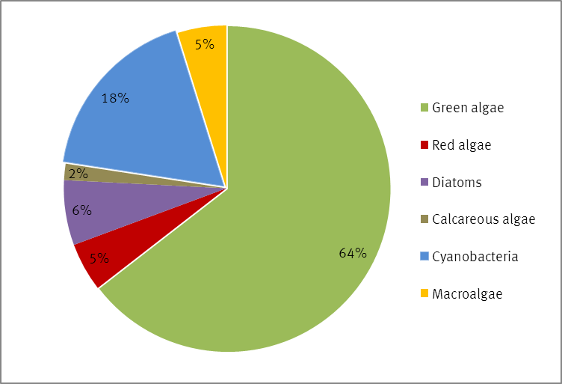

Figure 1: Used algae types in Germany.

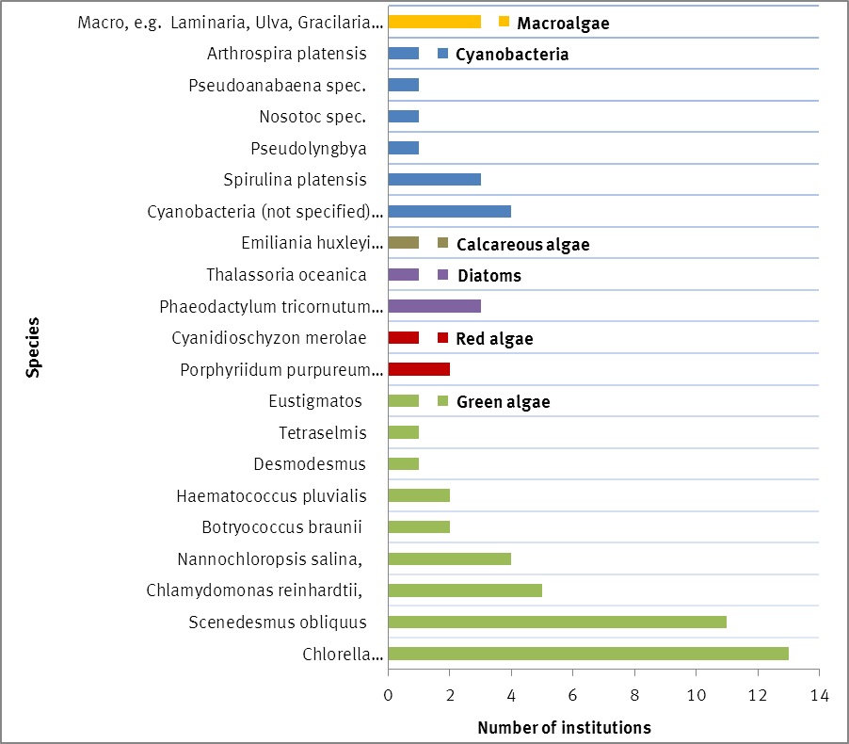
Figure 2: Number of institutions working with these algae species (multiple answers permitted).

Cultivation facilities
Over the last decade, constant and innovative research and development has been taking place in the area of algae cultivation technology. The presently used cultivation systems can be subdivided into following systems:

Table 2: Cultivation systems
Open/ Half-open production systems
- Open-Ponds
- Race-Way-Ponds
- Longlines
Closed photobioreactor systems (PBR)
- Flat bed/ Plate/ Flat panel reactor
- Tubular reactor
- Bag/ Flexible tube reactor
- Rain creating stack system („Horizon“)
- Fermentation vessel (heterotrophiccultivation)

Closed cultivation systems have the advantage of better controlling the cultivation conditions and, consequently, to guarantee the best temperature and light regime under almost sterile conditions.
Closed photobioreactors (PBR) are the most favoured facilities for cultivating microalgae in both, industry and academia in Germany. The most common systems are tubular photobioreactors followed by flat panel PBRs and plastic bags. Open ponds play only a minor role (4 research institutions and 1 commercial stakeholder; figure 3 and 4) in Germany. Flexible structures, such as long lines, and wild harvest are only considered by stakeholders working with macro-algae and therefore account for only a small proportion of the cultivation facilities in Germany. Many stakeholders run more than just one type of PBR.

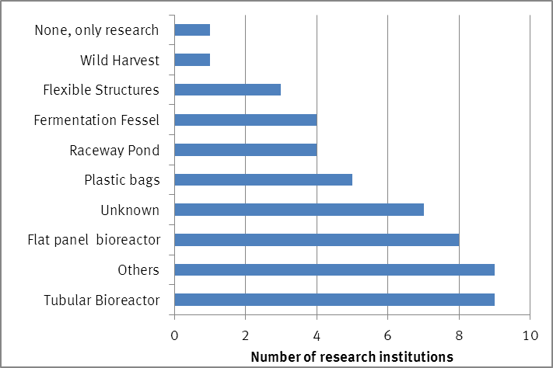
Figure 3: Cultivation facilities at research institutions

Either industry and research institutions have a strong interest in constantly improving their PBRs or, respectively, to test newly developed ones. This is mainly reflected by the number of stakeholders working with “other” PBRs than the most common ones named in the questionnaire (33 % of the research institutions and 22 % of the academic stakeholders; figure 3 and 4). Altogether, more different types of cultivation facilities are used at research institutions. In regard to size of the facilities there is naturally a big difference between academia and industry. Almost a quarter of the industrially used algae growth facilities comprise a volume of over 50 m³ (figure 5), whereas most of the research institutions use facilities with less than 2 m³ capacity. For most of the research institutions no data about the exact size of their algae growth facilities was provided.

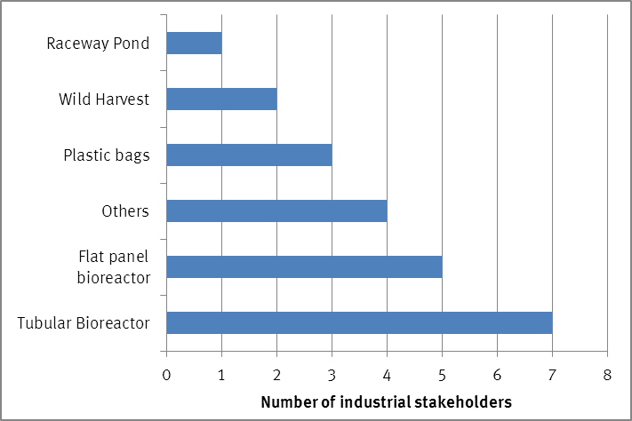
Figure 4: Cultivation facilities in industry

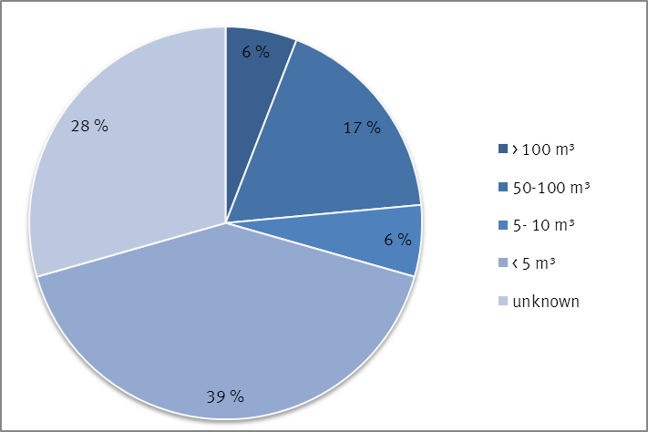
Figure 5: Average size of algae growth facilities in industry

Growth conditions
Almost three-quarter of the questioned stakeholders provided information about the conditions in their respective algae growth facilities. In respect to growth conditions, the survey did not go into too much detail, but rather concentrated on the origin of the three main substances: water, light and carbon dioxide. Multiple answers were possible.

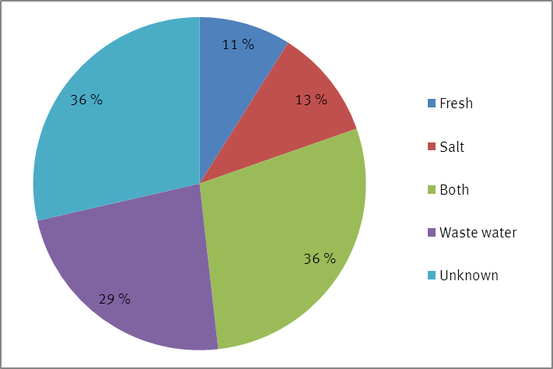
Figure 6: Growth condition - water

In regard to the growth medium, most of the stakeholders do not concentrate solely on either salt or fresh water species, but use both, fresh and salt water for the cultivation. However, the use of salt water slightly predominates when stakeholders are only focusing on one of the two mediums (figure 6).
More than a quarter of the stakeholders use waste water for algae cultivation. The waste water sources are quite different and comprise effluents from biogas plants, industrial and municipal wastewaters and residual or recirculation water from aquacultures.

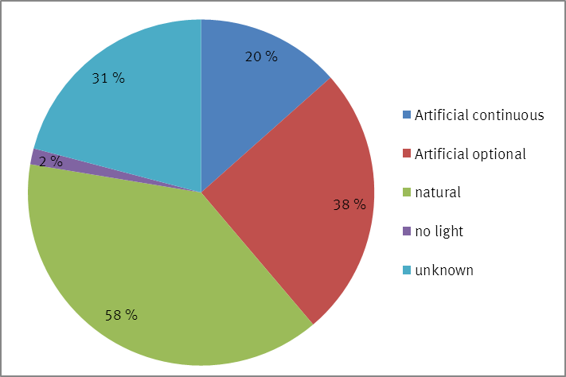
Figure 7: Growth condition - light

In terms of the light regime, the majority of the stakeholders, who provided respective information, use natural light for growing algae: 58 % solely rely on the natural radiation whereas 38 % of the stakeholders use artificial light when necessary (figure 7). Only 20 % of the stakeholders exclusively use artificial light for their algae cultivation. Only 2 % of the stakeholders have (also) focused on heterotrophic microalgae production and do not use any light.

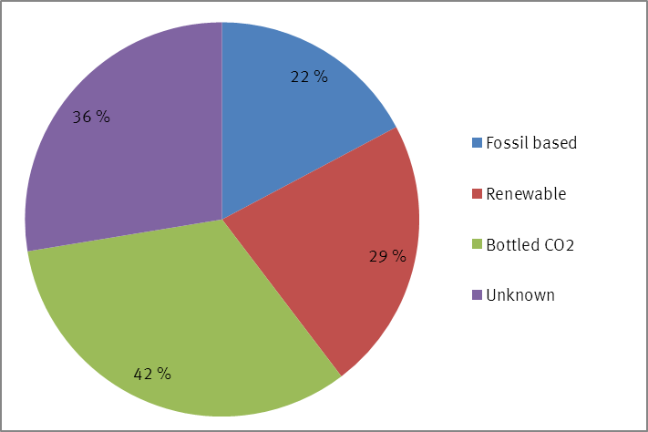
Figure 8: Growth conditions – CO2 supply

As for the carbon dioxide supply, most of the stakeholders are using industrially bottled CO₂ (42 %, figure 8). Renewable carbon dioxide is mostly used when algae production is combined with a biogas plant in which CO₂ is produced as side product. In one case the flue gas from a heat plant based on wood is used. Altogether 29 % of the questioned stakeholders use CO₂ from renewable resources. Stakeholders focusing on carbon sequestration install their algae cultivation facilities close to heat or combined heat and power plants (CHP) and use the fossil based flue gas for algae production (22 %).

Markets
As in the section on algal cultivation conditions, it needs to be emphasized that multiple answers were permitted since most algae stakeholders aim for more than one single product respectively market sector. The results have been summarized in the bar charts figure 9 and 10.
In order to determine the most promising market sectors for algae, the targeted products have also been grouped accordingly (see different colours in figure 9-10). Only one entry per market and per stakeholder has been counted for this analysis. The results are displayed in figure 11 and 12 and table 3.
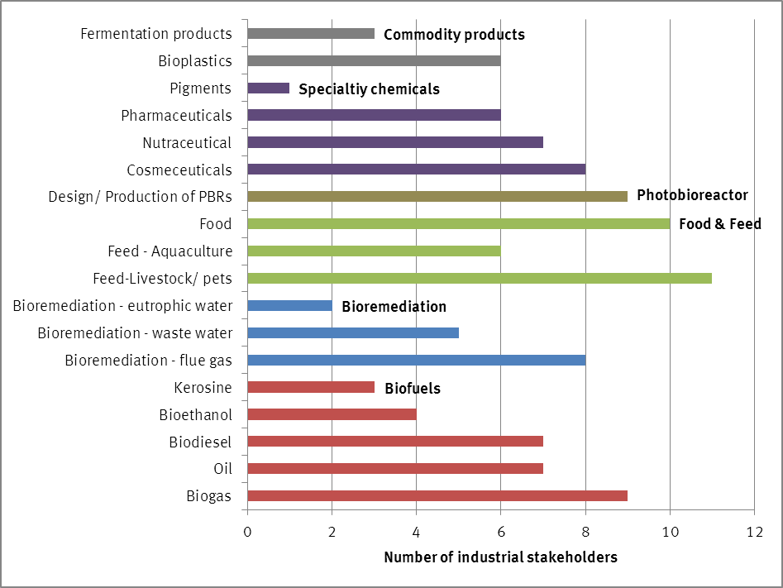
Figure 9: Targeted products of the industrial stakeholders (multiple answers were permitted; total number of stakeholders: 19)

The focus of scientific and industrial stakeholders is slightly different. Research institutions address a wider variety of aspects connected with algae cultivation and downstream processing and do more fundamental research compared to the stakeholders from industry. Quite frequently, a close collaboration between industrial and scientific stakeholders can be found in this area.
The majority of the cultivated algae in Germany are used for material purposes, like speciality chemical (cosmeceuticals, nutraceuticals, and pharmaceuticals), food and feed and other commodity products (e.g. bio-plastics and fermentation products). Algae-based bioenergy is an important field of interest as well, but is currently not practiced commercially. Algae production is still too expensive to successfully enter low cost and high tonnage markets like the one for bioenergy. However, strong research and development activities can be found in this area in Germany, particularly among the concerned research institution (32 % vs. 19 % of industrial stakeholders, figure 11-12).

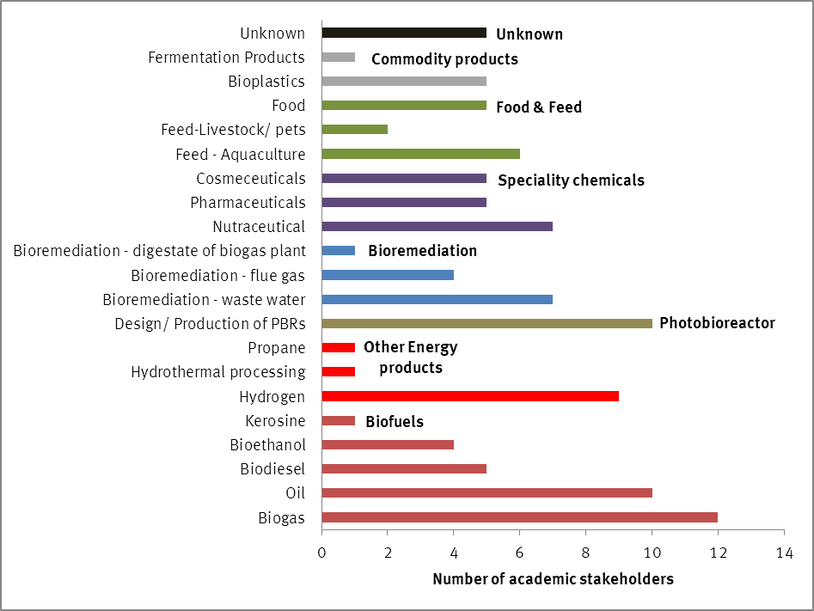
Figure 10: Targeted products of research institutions (multiple answers were permitted; total number of stakeholders: 27)

Beside typical biofuel products like biogas, oil, bioethanol, biodiesel and – to a very small extend - kerosene, some research institutions further examine alternative energy products like hydrogen, propane or products derived through hydrothermal processing (Figure 10). This offers promising approaches, but seems currently to be still too far from the market. Consequently, these pathways are mainly further developed in the context of research projects and are not yet pursued by commercial stakeholders. Hydrothermal gasification of algae is still in its early stages and, according this survey, respective research was only found at one research institutions.
As the survey has shown, the work with cyanobacteria is a field of interest for industry as well as for some academic research institutions (18 % of the used algae types in Germany; figure 1). Cyanobacteria are mostly used for ethanol or hydrogen production.
In comparison with the research sector, bioenergy is a less important product for industrial stakeholders. This might however change, if more efficient production, harvesting and/ or processing methods will be established.
In regard to the different energy product targets, algae-based biogas appears to be the main product (9 industrial stakeholders and 12 academic stakeholders; Figure 9 & 10). This can certainly be seen in connection with the use of algae for bioremediation, which has a share of 18 % and 14 % of the targeted markets for industry and research institutions respectively (Figure 11-12). Stakeholders concentrating on bioremediation frequently cooperate with either big power plants or biogas plants, in order to use the CO2 of the plants’ exhaust gas and the produced waste heat for algae cultivation. Algae produced under these circumstances can usually not be used as component for material products, like for instance food/ feed additives or cosmeceuticals, but are only be further used for producing bioenergy. Thereby production of biogas is still the cheapest option.

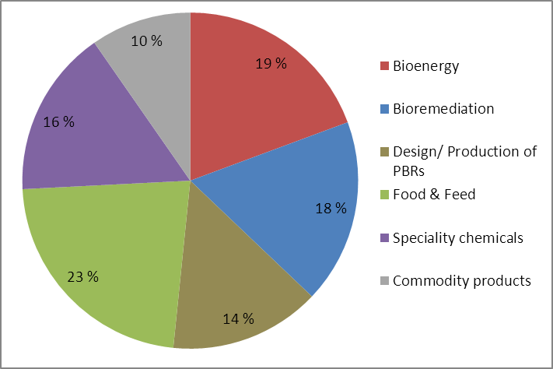
Figure 11: Targeted markets among industrial stakeholders

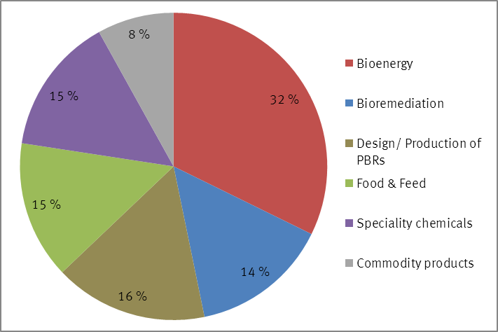
Figure 12: Targeted markets among academic stakeholders

Table 3: Targeted markets – number of stakeholders
Market | Industry  (19 stakeholders in total) | Research Institutions  (26 stakeholders in total)
Bioenergy | 12 | 20
Bioremediation | 11 | 9
Design/ Production of PBRs | 9 | 10
Food & Feed | 14 | 9
Specialty chemicals | 10 | 9
Commodity products | 6 | 5

For the industrial stakeholders, the market for food and feed is, with a share of 23 %, an important one. Complete algae as well as specifically extracted components and ingredients are used for this market. In comparison, this market sector accounts for only 15 % of activity within research institutions (Figure 11-12).
Another important market for algae is the one for “specialty chemicals”, i.e. specific components and ingredients that can be used in the production of cosmeceuticals, nutraceuticals and pharmaceuticals (15 % and 16 % of market share respectively; figure 11-12).
The focus within the specialty sector differs between industrial and research institutions. Industrial stakeholders have a stronger focus on cosmeceutical products (44 %, figure 9), whereas academic stakeholders have a greater interest in nutraceutical products (26 %, figure 10). There are attempts to further develop this market potential by looking for even more useful, algae-derived substances.
The use of algae for other commodity products like bio-plastics and fermentation products account for only a minor share (industry: 10 %; research institutions: 8 %) in the total targeted markets for algae.
One market branch inevitably connected with the cultivation and use of algae is the development and production of photo-bioreactors (PBRs). Half of the commercially active stakeholders (figure 9) as well as over one third of the academic stakeholders (figure 10) are significantly involved in designing and testing of photo bioreactors and frequently work together. Its overall share in the total targeted market sectors accounts for 14 % respectively 16 % (figure 11-12).

Underpinning activities
Besides their main focus of activity, most of the stakeholders are also involved in actions supporting their efforts in further developing and improving their targeted products. About 60 % of the stakeholders provided information about these underpinning activities.
The majority of industrial stakeholders (61 %; figure 13) are investigating new or further developing approaches for harvesting and processing algae biomass. Harvest and processing technology is also the main interest of the research institutions representing 22 % and 33 % of stakeholder activity respectively (figure 14). A further 26% of research institutions are occupied with activity associated with culture collection development.
Bioprospecting and research on valuable substances in algae was cited as an activity by a relatively small number of stakeholders, 11 % and 17 % of academic and industrial stakeholders respectively. Most of the questioned stakeholders seem to rather concentrate on the already well-known algae species, trying to optimize the cultivation, harvest and downstream processes and technology.
Genetical engineering for optimising algae (incl. cyanobacteria) plays currently only a minor role, which is probably due to the restricting legal framework in Germany. Nevertheless it is a topic for some of the concerned research institutions (7 %) as well as the industry (6 %) and might become more important in the future in the search for strategies for reducing production costs - particularly for the energy market.

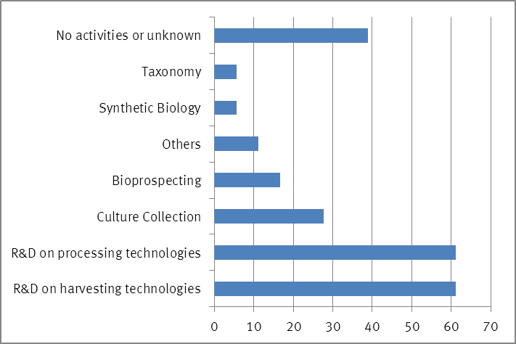
Figure 13: Number of industrial stakeholders (in %) involved in following algae related activities (multiple answers were permitted; total number of stakeholders: 19)

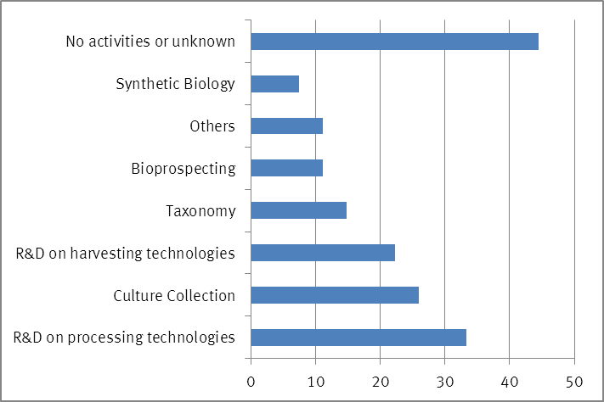
Figure 14: Number of academic stakeholders (in %) involved in following algae related activities (multiple answers were permitted; total number of stakeholders: 27)

Bioremediation refers to applications were algae are used for removing pollutants e.g. from power plant flue gas or from waste waters.

