**Energetic Algae (‘EnAlgae’)**

Project no. 215G

**Public Output**

OutputWP2A09.05 – Report on the state of algae related research and industrial activities in the UK

**Authors**

Adrian Higson, NNFCC

**Contributors**

[Insert author name], [insert author affiliation]

*Please cite this document as follows:*

Higson,A. 2014.Report on the state of algae related research and industrial activities in the UK, Public Output report of the EnAlgae project, Swansea, [month and year of release], [number of pages]pp, Available online at [website link].

*This document is an output from the Energetic Algae (‘EnAlgae’) project, which has received European Regional Development Funding through the INTERREG IVB NWE programme.*

*© EnAlgae project partnership, [date of release], all rights reserved.*

Report on the state of algae related research and industrial activities in the UK

Contents

1 Introduction 2

2 UK stakeholders 3

3 Types of algae 11

4 Cultivation facilities 12

5 Growth conditions 13

6 Markets 14

7 Research 15

8 Underpinning Technology 16

# Introduction

In 2012-2014 an inventory of North-West European algae initiatives was carried out to provide an impression of research and commercial activities connected to algae production and utilization. The collected data has been reviewed in country specific reports and collated and summarised in an overview report covering the whole North-West-Europe region (including Great Britain, Ireland, Germany Belgium, France, Switzerland, Luxemburg and the Netherlands).

Data was obtained via a comprehensive questionnaire which was distributed among stakeholders identified in a preliminary scoping exercise. Although not unexpected, unfortunately not all questionnaires were returned. In these cases, publically available information was used for the landscaping study and some additional information was collected through personal interviews with the respective stakeholders. The questionnaire aimed to gather more information on focus, expertise and applied technology of the addressed institutions. It was also designed in a way that allows its use as an information sheet in EnAlgae’s web-based information portal.

This report summarises the results of the analysis of data collected the UK, where 24 % of the sent-out questionnaires were returned by the stakeholders. Due to the low rate of return further information on the expertise of research institutions in the UK was taken from a comprehensive survey undertaken in 2011 for the BBSRC[1].

In this context it must be emphasized that this report cannot claim to reflect an exhaustive list of all stakeholders active in algae research and business. The reasons behind this are that it is a rather broad area and in some cases only very limited information is available about respective activities. In addition, there is lots of movement in this sector with regard to new start-ups and the closing down of business operations, making it difficult to give an up-to-date overview. If too little information could be found about certain institutions they were not included in this survey.

However, this study nevertheless represents the most important institutions active in this area, allowing conclusions to be drawn about the main fields of interests, technology and market opportunities for algal research in the UK.

# UK stakeholders

In total 82 institutions working with algae could be identified in the UK. The majority of these stakeholders (73 %) are research institutes and the remaining 27% industrial organisations. The following table (Table 1) gives an overview about the identified stakeholders and a number of consortiums, networks and multi-partner projects.

The following pages present the results of survey results for UK research institutions.

Table 1: Overview of UK stakeholders active in the broader algae area

|  |  |
| --- | --- |
| Consortiums, Networks & Multi partnerprojects | |
| Algal Bioenergy Special Interest Group (AB-SIG) | Jointly funded by Natural Environment Research Council (NERC) and Technology Strategy Board (TSB). The Special Interest Group runs networking events and produces reports on the research challenges for algae as well as a future technology roadmap.  The network‘s high-level science goal is understanding the opportunities and risks to the quality of freshwater and marine environments of using algal biomass as a source of renewable energy and chemicals. |
| AlgalBiotechologyConsortium | University of Cambridge, Rothamsted Research, University College London, and collaboration with industrial partners.  The consortium brings together molecular biologists, physiologists, chemists, engineers and chemical engineers to facilitate the development of future biotechnology and bioenergy solutions.  Current work includes:   1. The development of tools in algal molecular and synthetic biology for accumulation of desired products 2. The production of algal biomass, including sequestration of CO2 from flue gases, and treatment of wastewater 3. Use of cyanobacteria for the production of bio-photovoltaic panels 4. Photosynthetic and biomimetic hydrogen production and CO2 reduction |
| Algal Biotechnology Knowledge Transfer Centre (KTC) | The Algal Biotechnology KTC provides access to R&D, cutting-edge facilities and expertise.  The project, based at the Centre for Sustainable Aquaculture Research (CSAR) at Swansea University, provides:   * up-to-date information and advice on microalgal bio-technologies, regulatory frameworks and markets; * access to industry-focused research and technological development to assist with the development of new products, processes, and services; * access to demonstration and training facilities. |
| Biomara | The Sustainable Fuels from Marine Biomass project, BioMara, was a joint UK and Irish project that aimed to demonstrate the feasibility and viability of producing third generation biofuels from marine biomass.  Project partners: Scottish Association for Marine Science (SAMS), Centre for Renewable Energy at Dundalk Istitute of Technology, Fraser of Allander Institute at University of Strathclyde, University of Ulster, Institute of Technology Sligo, Queens University Belfast. |
| Marine Alliance for Science and Technology Scotland (MASTS) | A consortium of organisations engaged in marine science, MASTS represents the majority of Scotland's marine research capacity. |
| Nottingham Microalgal Biorefinery | Research facility operated in partnership between the Boots Company and Plymouth Marine Laboratory. |
| Oasis Project | The Oasis Network from Cranfield University aims to disseminate information on the technological and commercial opportunities in this area to the supplier community in the region. |
| SeaweedHealthFoundation | The Seaweed Health Foundation is an independent and  not-for-profit forum for research, and to raise awareness of the benefits of human food quality seaweed for food and health. |
| Research Institutes | |
| University of Aberdeen | Expertise includes bioactive natural products from marine organisms, deep time algae ecology, algal culture, isotope enrichments, fatty acid analysis, fate of algae material in marine ecosystems, and oomycete-algae interactions. |
| Aston University | Expertise includes chemical engineering applied to bioenergy and biofuels. |
| Bangor University | Involved in large scale algal biomass/biofuels production. |
| University of Bath | Research interest in Algae Biotechnology including thermo-tolerance, increased photosynthetic efficiency and reduced harvesting and product recovery costs. |
| University of Birmingham | Expertise includes algal bi- adhesion and biofouling, plant development and evolution, environmental toxicology, improved light delivery and photobioreactor development. |
| Bournemouth University | Expertise includes microalgae culture, physiological assessment, flow cytometry, and metabolic stains. |
| Birmingham City University: Centre for Low Carbon Research (CLCR) | Engaged in a number of applied research projects investigating the cultivation of microalgae and its conversion into biofuels and biogas  Research is focused on improving the environmental sustainability and commercial viability of bioenergy production. Current research interests include:   * Cultivation of biomass on wastewater sources * Optimisation of lipid productivity and extraction in microalgae * Impact of ultrasonic cavitation on organic compounds * Investigating the influence of combustion exhaust composition on algal cultivation and its potential for CO2 sequestration * Impact of wastewater substrates on CO2 sequestration by microalgae. * Investigation into digestion and co-digestion of algal biomass and impact of biomass pre-treatment. |
| University of Cambridge | Expertise includes evolution of biosynthetic pathways and photosynthesis in plants and algae, bioenergy, carbon capture, functional genomics tools (RNA), algal-bacterial symbiosis, freshwater ecology, bioremediation, algal bio-photovoltaics, molecular genetics of algae, and process engineering and reactor design. |
| University of Cardiff | Expertise includes productivity, photo-physiology, coastal erosion and bio-stability, lipid biochemistry, and molecular biology. |
| Centre for Environment, Fisheries and Aquaculture Science (CEFAS) | Expertise includes flow cytometry, phytoplankton, productivity, and the North Sea |
| Centre for Ecology and Hydrology (CEH) | Various projects including an NERC application to develop concepts on harvesting algae for lake restoration (and possible resource capture).  Research includes phytoplankton responses to environmental change, cyanobacteria responses to nutrients and flushing.Applied research includes WFD classification schemes for phytoplankton, and lake restoration studies. |
| University of Coventry | Part of the Carbon Trust Algal Biofuel Challenge project between 2010 and 2012. Macroalgae research includes the extraction of microalgal lipids for the biofuel industry using ultrasound, the effect of ultrasound on the growth and viability of algal species, and stressing techniques to induce lipid production. |
| Centre for Process Innovation (CPI) | Three current and recent projects:   1. EU FP7 InteSusAl: Demonstration of integrated & sustainable enclosed raceway and photobioreactor microalgae cultivation with biodiesel production and validation 2. Algae CoFiring: Addressed industrial carbon abatement through evaluating the technical and economic feasibility of using algal biomass as a partial replacement for fossil fuels in a rotary kiln, used for the production of dolomitic lime 3. AlgaeCAT: aims to develop an innovative, low cost, algae-based carbon abatement system for the the capture of industrial scale CO2 emissions. |
| Cranfield University | Partner in the ATWARM project and other research activities. Current research interests include the use of algae for nutrient removal and energy recovery. |
| University of Dundee | Expertise includes biophysics, biochemistry, physiology, ecology, evolution, environmental change, and molecular biology. |
| University of Durham | Expertise includes cell biology, lipid metabolism, DNA array, photosynthesis, enzymology, cyanobacteria gene regulation and transformation. |
| University of Edinburgh | Expertise includes experimental evolution in microalgae, microbial ecology in high CO2 environments, and chemistry of the polysaccharides of charophytes in relation to early land plant phylogeny. |
| University of Essex | Expertise includes photosynthetic energy conversion, microalgae culturing, environmental stress, nutrient requirement and limitation, algae proteomics, resource allocation strategies (optimality modelling), phytoplankton ecology, ecophysiology of marine algae, marine nutrient cycling and environmental change, carbon allocation and production of extracellular products. |
| University of Exeter | Expertise includes lipid metabolism, primary carbon and nitrogen metabolism, antioxidant systems and reactive oxygen species. |
| Glasgow Caledonian University | Current research includes the anaerobic digestion of micro and macro algae for biofuels. |
| University of Glasgow | Expertise includes synthesis of bioactive marine natural products, and biofuel (lipids) and hydrogen production. |
| University of Greenwich | Expertise includes bioremediation, and integration of algal growth with AD. |
| Heriot Watt University | Current research interests include the distribution of estuarine algae in relation to environmental factors, long-term changes in the algal flora of the Forth and Clyde estuaries, development and taxonomy of green algae, and the development of toxicity testing by green algae. |
| James Hutton Institute | The organisation combines strengths in crops, soils and land use and environmental research, and aim to contribute to the understanding of food, energy and environmental security; and to develop and promote effective technological and management solutions to these. |
| Institute of Biological, Environmental & Rural Sciences (IBERS) | Research includes the conversion of macro algae to ethanol through fermentation. |
| Imperial College London | Expertise includes natural products, molecular biology and bioinformatics. |
| Lancaster Environmental Centre (LEC) | Expertise includes molecular ecology, taxonomy, molecular markers and harmful algae. |
| University of Leeds | Expertise includes algae-based waste water treatment in middle and low income countries, algal biofuels including environmental and economic assessment, and life cycle analysis. |
| Loughborough University | Expertise includes diatom ecology and palaeoecology, biogeochemistry of silica, and limnology. |
| University of Manchester | Expertise includes fermentation processes, and biorefinery engineering. |
| University Marine Biological Station Millport | National facility for marine biology fieldwork, and institute of the University of London. |
| Edinburgh Napier University | Research within environment, sustainability and society encompasses marine and coastal biodiversity and conservation and management, including the production of biofuel from waste products, and the exploitation of microorganisms for bioremediation. |
| Natural History Museum | Current research includes taxonomic, phylogenetic and environmental research. |
| Newcastle University | Current researchincludes offshore cultivation of algae, anaerobic digestion of macroalgae, and seawater algae for biodiesel, and culture management for biodiesel production. |
| University of Nottingham | Expertise includes chlorophyll and carotenoid pigments, palaeolimnology, aquatic ecology, lichen ecology, and nitrogen fixation in cyanobacterial lichens. |
| Plymouth University | Expertise includes macroalgae ecology, carbon sequestration, ocean acidification, and solar conversion of energy. |
| Marine Biological Association | Expertise includes algal cell biology, algal development and signaling and isolation and culturing of marine microalgae. |
| Plymouth Marine Laboratory | Expertise includes algal biochemistry and molecular biology, algae viruses, bioprocessing, biotechnology and biocatalysis, biofuel production, and drug discovery. |
| University of Portsmouth | Expertise includes marine aliens, molecular ecology, biogeochemistry, and algae-nutrient interactions. |
| Queen Mary University | Expertise includes cell biology, biophysics, and regulation of photosynthesis, biogenesis and turnover. |
| Queens University Belfast | Current research includes development of a pilot scale macroalgal cultivation facility. |
| Royal BotanicalGardens Edinburgh | Expertise includes biology of microalgae, especially diatom systematics and evolution, community ecology, taxonomy and climatic distribution, with a focus on Scottish bank mires. |
| University of Reading | Expertise includes the health benefits of phytochemicals. |
| Robert Gordon University | Research into Cyanobacteria. Aim to develop sustainable solutions for algae related problems in the aquatic environment in parallel with the exploitation of their diverse biosynthetic capabilities. |
| Rothamstead Research | Expertise includes lipid metabolism and metabolic pathways. |
| The Scottish Association for Marine Sciences (SAMS) | Expertise includes biological resources, algal biofuels, algal biotechnology, protistan cryopreservation, protozoan and algae culturing, algal disease and pathogens, algal functional and environmental genomics, and oomycete-algae interactions, |
| University of Sheffield | Expertise includes metabolic engineering, synthetic biology, systems biology, proteomic, bioreactor design, transport processes, membrane assembly, algal growth and biotechnology. |
| National Oceanography Centre, University of Southampton | Expertise includes molecular biology of chloroplast development, photobiology, tetraprroles, algal biofuels, photosynthesis in marine systems, algal bloom control, and marine taxonomy. |
| University of St Andrews | Expertise includes fisheries, bioactive products, microalgaldefence, informatics, genomatics, phylogeny, diatoms, coastal ecology, biodiversity and ecosystem function, coastal ecology, and sediment analysis. |
| University ofStirling | Expertise includes conservation biology, underwater optics, remote sensing and cyanobacteria. |
| University ofStrathclyde | Expertise includes regional economic-energy-environment modelling. |
| Swansea University | Current fundamental research includes algal physiology aspects, and applied research includes waste bioremediation, and high value compounds production. |
| Teesside University |  |
| University College London | Expertise includes diatoms, ecology and palaeoecology, shallow lake and pond palaeolimnology, limnology, palaeoecology, wetlands, lakes, algal biotechnology, genetic engineering, and orgenelle biology. |
| University of East Anglia | Expertise includes functional genomics and reverse genetics, and cyanobacteria gene regulation and transformation. |
| University of the West of England (UWE) |  |
| University of Ulster | Expertise includes lake processes and production |
| University of Warwick | Expertise includes molecular ecology of marine picocyanobacteria and photosynthetic picoeukaryotes, niche adaptation mechanics in marine picocyanobacteria, picoyanobacteria genomics and molecular biology. |
| University of Westminster | Expertise includes microalgal life cycles, dinoflagellates, taxonomy, isolation and cultivation. |
| University of York | Expertise includes ocean-atmosphere interaction, macroalgal volatile emissions, seperationsand natural products, algal polysaccharides |
| Industrial Organisations | |
| Algaecytes | Aim to commercialise the next generation of algae technologies using nutrient-rich recovered waters and carbon dioxide from industrial processes. |
| Algenuity | Algal biotech company develops and provides the Algemlabscalephotobioreactor for algae and cyanobacteria research. |
| Aragreen | Use microalgae in enhanced waste water treatment and in the production of a range of algae containing anti-oxidants, pigments and proteins for human. |
| Autophagix | Biotech company with ambitions to design and develop novel therapeutics for autophagy modulation and the treatment of inflammatory disorders. |
| BodAyre | Produce and dsitrubute organic seaweed plant feed and animal feed supplement products, and edible seaweeds for human consumption from Shetland coastal water seaweed, and farmed seaweed. |
| Enebio | A technology and innovation consultancy specialising in the introduction of new technologies into the water and wastewater, bioenergy and micro-generation sectors. Enebio are actively involved in algae research and developing specific technologies for growing and harvesting micro algae. |
| Enlightened Design Limited | Develop algae culturing systems, with a focus on low-cost , low-energy systems. |
| Glycomar | A marine biotechnology company developing novel anti-inflammatory drugs from marine glycobiology. |
| HebrideanSeaweed Company | Hebridean Seaweed Company harvest wild seaweed and processes it into high quality environmentally friendly organic seaweed products. |
| IrishSeaweed | Harvest and distribute wild seaweed for the food market. |
| Loch Duart | Primarily a salmon farming company, combining sea urchin and macroalgae cultivation. |
| NeoAgro | Use macroalgae to filter out microalgae from ecologically sensitive areas. |
| Mara | Scotish seaweed brand selling native seasonal seaweeds as value added products into the food market. |
| Marine Biopolymers Ltd | Developing new technologies for high value chemical extraction from seaweeds, and manufacturing projects. The first target project is a plant manufacturing alginate to be based on the island of South Uist. |
| Merlin Biodevelopments | Provider of algae products for the food and feed sectors, have developed their own bioreactors. Acitve in researchactivities. |
| New Horizons Global | Biotechnology company, using fermentation technology on microalgae to produce Omega-3 lipids for the food, feed and pharmaceutical industries. |
| OrkneySeaweed Company | Orkney Seaweed Company manufactures a range of products based on liquid extraction from freshly harvested seaweed, for use in orticulturea and agriculture. |
| SeaVeg | Harvest and distribute wild seaweed for the food market. |
| Scottish Bioenergy | Design, install, and operate small scale flat plate panel reactor systems for carbon capture, waste water treatment and biochemical production. |
| Varicon Aqua Solutions | Provide algae production expertise across a range of sectors. Design and manufacture the BioFencephotobioreactor. |
| Viking FiahFarms | Produce algae for aquaculture and hatcheries markets, using bag systems. |

# Types of algae

The majority of research institutions are working with micro algae (64%), with a minority working solely with macro algae (7%) and the remainder working with both micro and macro algae.

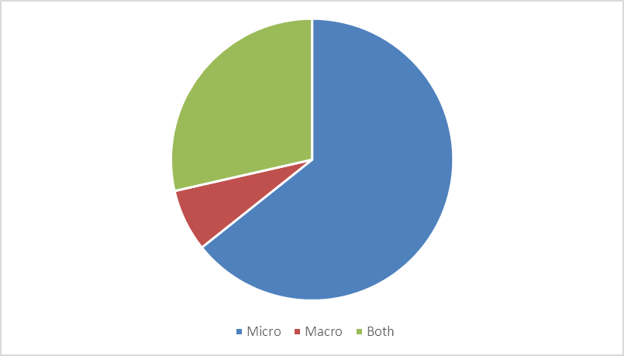

Figure 1: Broad types of algae utilized by UK’s algae stakeholders

A small number of respondents provided details of the precise algae species they are working with, those identified are listed in table 2.

Table 2: Types of algae listed in survey results

|  |  |
| --- | --- |
| Alaria | Cyanobacteria |
| Arthrospira | Cyanothece |
| Ascophyllumnodosum | D. salina |
| bladedBangiales | greenendophytes |
| Botryococcusbraunii | Isochrisis |
| C. concordia | Laminaria |
| Chaetoceros | Nannochloropsis |
| Chlamydomonas | N. oculata |
| Chorella | Saccharina |
| ColinialChlorophyte | Scenedesmus |
|  | Tetraselmis |

# Cultivation facilities

Tubular photobioreactors are the most common system for cultivating microalgae in the UK, followed by plastics bags. UK research institutions area also using raceway ponds, fermentation vessels and longlines, flexible structures, and flat panel photobioreactors.

Other reported cultivation facilities include photobioreactors. Little information was provided on the scale of cultivation facilities, the largest reported scale was 600 litres for micro algae and over 7 ha area for the cultivation of macro algae.

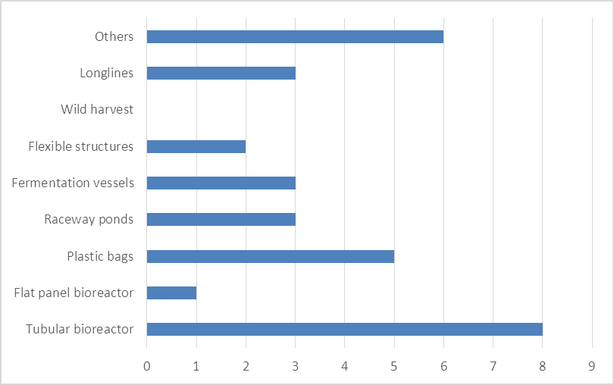

Figure 2: The cultivation facilities used by UK research institutions: number of institutions

# Growth conditions

The majority of responders provided no details of the growth conditions, either the water or light sources used, the results of those that did are illustrated below.

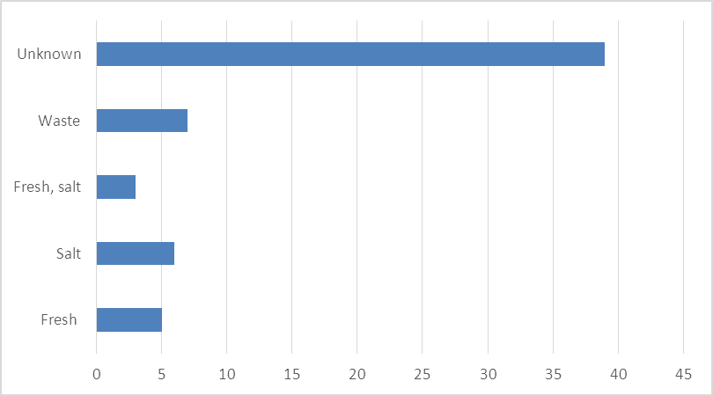

Figure 2: Number of research institutions employing each water source

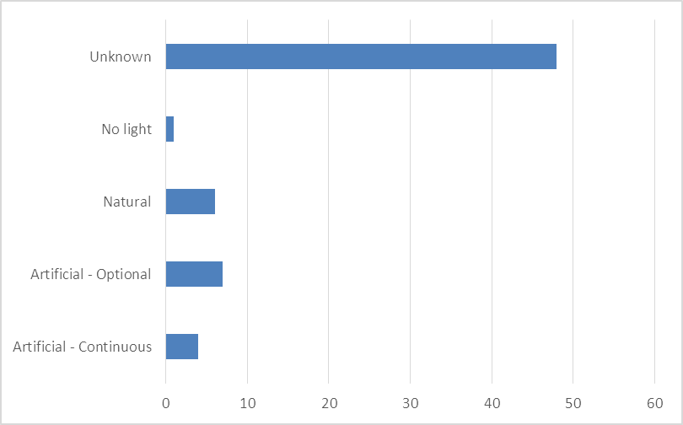

Figure 3: Number of research institutes employing each light source

# Markets

The most common target markets for macro algae research are bioenergy, with specific focus on AD, and food products. For microalgae, there is a more even spread of interest across market applications, with greatest interest in bioenergy, and interest in the speciality chemicals sector, bioremediation, commodity chemicals and food and feed.

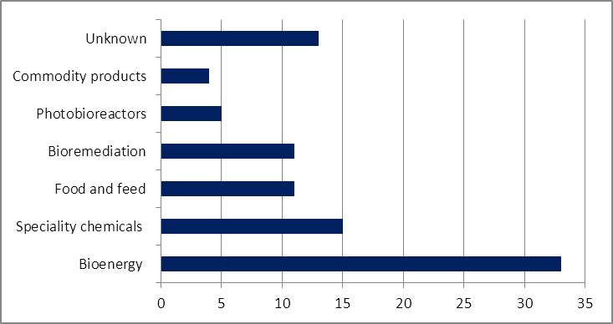

Figure 4: Target markets for research institutions using algae in the UK (multiple answers permitted, number of responses 48)

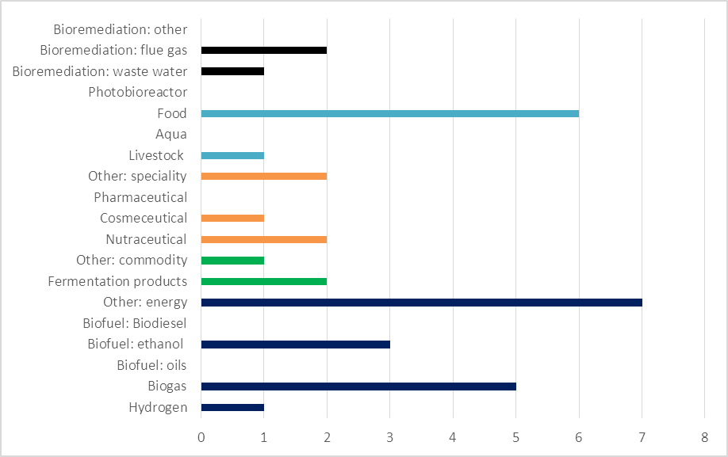

Figure 5: Target markets for research institution using macro algae in the UK

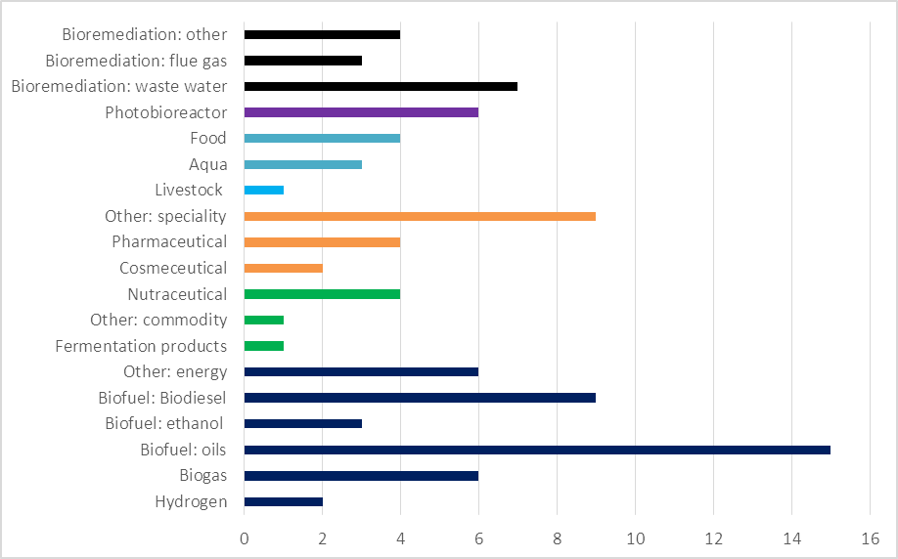

Figure 6: Target markets for research institutions using micro algae in the UK

# Research

The focus of research carried out in UK research organization includes biotic and abiotic interactions, life cycle analysis, modelling and disease. However, unfortunately no information was supplied by a large number of surveyed parties.

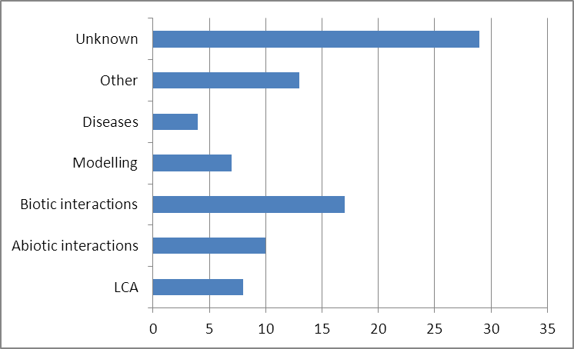

Figure 7: The algae research interests of UK research institutions: number of universities

# Underpinning Technology

A large number of surveyed parties did not provide detail of the underpinning technologies relating to their research in algae. However 25 research institutions had underpinning expertise and on-going research in Taxonomy, and a significant number of research institution were active in processing technology and harvesting technology.

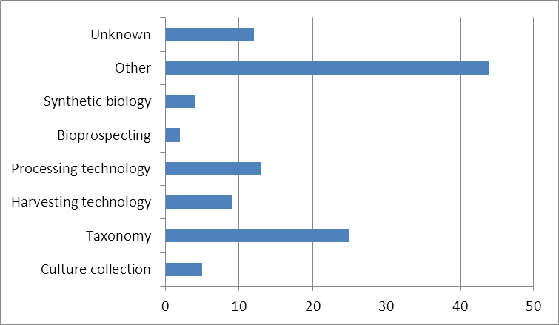

Figure 8: Number of UK research institution involved in various algae related activities

1. B. Schlarb-Ridley, Algal Research in the UK, 2011